September 2023
Overarching aims and ambitions | p.2
School rules | p.3
What do we expect from pupils | p.4
What do we expect from staff | p.5
What do we expect from parents and carers | p.6
Recognition and praise | p.7
Unacceptable behaviour | p.9
Consequences | p.11
Support for children not meeting expectations | p.13
Searching and confiscation | p.14
Use of reasonable force | p.15
Flowchart of Stages and intervention | p.17
Appendices
Lunchtime slip | p.18
Behaviour letter to parents | p.19
Behaviour categories | p.20
Bullying incident log | p.21
Reading alert | p.22
PE kit reminder | p.23
Correct uniform reminder | p.24
Supplementary Guidance Booklets
A guide to Coaching Sessions
Scripted language prompts
A guide to consequences and scenarios
Behaviour Policy

Our overarching ambition is to create an inclusive school where children’s behaviour is not only managed but is changed so that they become citizens that contribute positively to the communities they live in. We adopt a therapeutic approach to understand barriers children may have and empower them to take responsibility and find solutions with everyone’s support.
At the heart of this policy lies our vision
Every child deserves a champion – we will never give up on you. We want you to achieve all the goals you set yourself and more!
We will insist you become the best you can possibly be in every way. We are aspirational.
We recognise no one is perfect. You will learn from your mistakes and we will celebrate these learning opportunities as we move forward together.
We are resilient and reflective.
There is an adventure in learning waiting for you. It’s a long road ahead but we promise to make sure no path is blocked and no door is closed to you.
We are determined and positive.
Reading and inspirational experiences will take us further as we seek to rise above the ordinary.
This is learning without limits and will only happen when behaviour is exceptional!
Every day, in lots of different ways, our pupils ask: do I matter to you, do you notice me, do I belong here?
Yes, they do matter. Yes, we do notice them each and Yes, they do belong and we aim to show it every day.

Our school rules apply equally to everyone involved in our school: staff, pupils, parents and visitors.

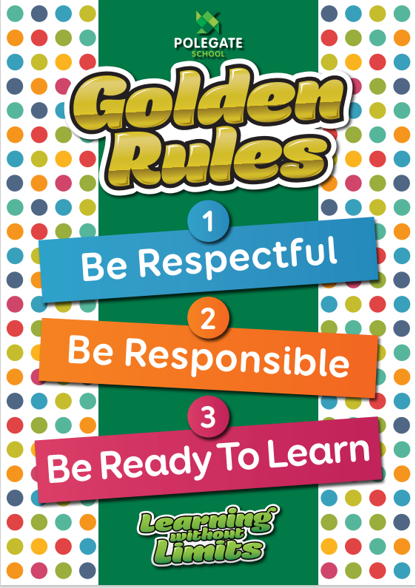
They are reinforced continuously by example and by a conscious policy of praise, thanks and encouragement.

What do we expect from pupils?
These are our norms

Pupils will be expected to:
- Children will move quietly and sensibly about the school, never running or shouting.
- Children will hold doors open for others.
- Speak politely to everyone else, using a low voice.
- Greet, welcome and smile at all adults and other children as you pass them in the corridor or on school grounds
- Tuck chairs under their tables every time they leave their seat
- Follow reasonable instructions given by the teacher
- Show respect for the opinions and beliefs of others
- Wear their uniform with pride, not tying a jumper around their waist and shirts tucked in.
- Complete all class work in the manner required
- Show respect for the working environment keeping their work space organised and clutter free.
- Keep all four legs of the chair on the floor (no swinging) (this may be challenging for certain SEND groups such as ASD and adaption is made accordingly)
- If asking a question, put hand up (no shouting out)
- Listen to someone who is speaking, looking at them. (this may be challenging for certain SEND groups such as ASD and adaption is made accordingly)
- Keep the cloakroom tidy and ensure bags, lunchboxes are stored safely
- Wait to the left opposite their lockers quietly to collect items at the start and end of the day.
- Children will respect others personal space.
- Keep the school tidy by using bins properly including picking up all things from the floor even if they are not responsible for them.
- When out of school, whether walking locally or with a school group, we expect that children should be aware that the school’s reputation depends on the way they behave.
- Children will not get up from their seats in lessons for the teacher or TAs attention, eg. Showing work.
- No rough, boisterous play or contact is permitted.
Lunchtime specific:
- Children will not talk with food in their mouths.
- Children will use knife and fork developing expected etiquette.
- Children will clear their own plates and cutlery once finished.
All adults consistently and at all times remind children of ‘norms’ when they see them not being followed.

What do we expect from staff?

Staff will be expected to:
- Establish the norms in and around the school with all children so everyone knows what to expect
- Display the school rules prominently in every classroom
- Teach expected behaviour and routines in the same way the curriculum is taught and model practice reinforcing again and again!
- Expect nothing less than high standards and expect the best with no lost learning time
- Praise at every opportunity, immerse them in a school where good conduct is seen, recognised and expected.
- Greet and welcome all pupils individually at the door on arrival and after lunch
- create a swift and purposeful start to lessons
- contact parents with positive messages about children’s behaviour where it is above and beyond.
- contact parents as soon as concerns arise about a child’s behaviour
- reinforce clear expectations of behaviour
- deliver a suitably planned and structured lesson which meets all individual needs
- show respect for the working environment, keeping the classroom organised and clutter free.
- Manage the class locker area and reinforce expectations for shared areas in school
- Speak politely to everyone else, using a low voice. (shouting should be avoided unless a member of the school community is in danger)
- Look smart and professional
- deal with incidents of inappropriate behaviour by following the school’s procedures
- promote and reinforce positive behaviour in the classroom
- follow the school rules: respect, responsibility and ready
- model our vision and aims in order that we are exceptional at all times. We expect positive habits and behaviour will be shown by all.
Keep your thoughts positive because your thoughts become your words. Keep your words positive because your words become your behaviour. Keep your behaviour positive because your behaviour becomes your habits. Keep your habits positive because your habits become your values. Keep your values positive because your values become your destiny. -Mahatma Gandhi
What do we expect from parents/ carers?

Parents and guardians are expected to:
Most importantly: support, understand and uphold our policy. Teaching children to take responsibility within established rules they understand is important. It helps them feel safe and grow up to be a prosocial and well-rounded individual with positive self-esteem. It prepares them for life beyond school. We ask parents to enforce the necessary rules and limits alongside the school in a firm but gentle manner. Your children will thank you for it.
- work in partnership with staff to ensure positive behaviour is developed
- send children to school on time and maintain good attendance of at least 97%
- send children with full school PE kit (see handbook)
- send children to school in full agreed school uniform (see handbook)
- inform staff of any concerns or issues that impact on their well being
- respond to concerns raised by members of staff
- ensure pupils come to school correctly equipped and prepared to work
- trust us, as a school community, sometimes messages may be difficult to hear but please remember that we want the very best for your child
- don’t make excuses for your child’s behaviour, every child tests limits, makes mistakes and pushes the boundaries from time to time. We are not judging you.
- Hold your child to account for their behaviours and actions.
- establish healthy routines, limits and boundaries at home to ensure they are prepared for school each day.
- Encourage and support children to complete home learning expectations
- follow and model the school rules: respect, responsibility and ready
We expect adults in the school to conduct themselves appropriately as role models for the children.
The School and the Local Authority consider any threatening, abusive or violent behaviour to be a very serious matter. This type of behaviour causes extreme distress to all concerned and it is not acceptable. Aggressive and threatening behaviour will not be tolerated on school premises. Permission to be on School premises can be withdrawn.
Recognition

Positive recognition for behaviour and learning is a focus and given priority at Polegate. Rewarding good behaviour must be the norm and it is the responsibility of all adults in school. It must be remembered that good work and good behaviour go hand in hand. Raising the self-esteem of every child is a priority. Children who are appropriately challenged and experience success feel a sense of achievement, pride and self-worth. Be generous with rewards.
Learning
- learning stickers for good work. These are stuck onto their ‘Learning without Limits’ bookmark. After 10 learning stickers have been awarded the child is presented with a ‘Learning without Limits’ Certificate in Assembly.
Behaviour
- House points, coloured tokens are awarded for positive behaviour. A maximum of 1 token can be awarded at any time. These are collected in the classrooms then collectively put into their house tubs in the entrance and counted each week on a Friday. The winning house is announced in Monday’s assembly.
- The four houses are: Phoenix- resilient, Pegasus - aspirational, Hercules - determination and Orion - reflective. School staff also belong to a house.
Any of the following
Star of the week
Parents and pupils highly value this reward and the children themselves decided on the criteria for being given this as part of Polegate Parliament.
Children who consistently try their best and who behave in a kind and thoughtful manner, following all school rules are eligible to be awarded ‘Star of The Week’.

Criteria to follow when making decisions about Star of the Week:
- It is designed to reward those children that are always good and well behaved. Therefore, behaviour must have been good for at least a term.
- It is not designed to recognise improved behaviour over a short period no matter how tempting this may be for the teacher. there are other rewards that can be used instead.
- Teacher should consider attendance and lateness. A child that has poor attendance (below 90% over a year unless valid medical reasons), lots of holidays should not be awarded Star. Conversations should happen between the teacher and parents regarding this.
- A child may get it more than once.
- A child may never get Star of the Week if they are not meeting the criteria.
- Engagement with home learning is considered and minimum expectations are met.

The whole school community recognise this as a very special award and they feel it gives them something to aspire to and aim for. We are proud of the drive and determination our children demonstrate to achieve this. It recognises those children that are always good and consistently maintain those high expectations that may otherwise go unrecognised.

Spotlight moment
This is an award which recognises a ‘WOW’ moment for an individual child!
There is no expectation that there is one each week for a child from each class. When selected it will only be one child in a class for that week. It is different to Star of the Week. This recognises huge success for an individual
Unlike Star of the Week it does not require the consistency and may not be linked to behaviour, in this way we ensure that each and every child at Polegate is recognised for their own unique strengths and talents.

There is no reason for a child to go unnoticed with these two rewards in place.
In addition, there are a multitude of other rewards

Other ways to recognise success
- Phone call home
- Letter home
- Seesaw
- Tapestry
- Headteacher commendation
- Sending child to share good work/behaviour with another class / teacher / headteacher
- Work may be displayed in public areas around the school-special work boards.
- Mention in newsletter or website.
- Inviting parents in to share good work after school
- Positive comments on child’s work/ behaviour
- Showing good work in Class Assemblies
- Praise Postcards
- Twitter post
- Above and beyond postcards
- Attendance awards and prizes.
- Golden housepoint (community commendation for something special outside of school eg. Calling ambulance, charity work)
- Special mention in assembly
- Publication of work
- Hot chocolate with teacher and member of the senior leadership team
- Recognition of outstanding behaviour
- Verbal thanks, praise, encouragement - in private – and in public
- (Children might clap to acknowledge good behaviour/work)

Dealing with unacceptable behaviour
Class time

It is the responsibility of class teachers to deal with minor incidents which occur in the classroom. Prevention is key to diffusing situations and preventing escalation staff will use many of the invisible stages to support this listed on p.14. Minor incidents may include, for example: throwing paper; calling out; not following instructions; incomplete class work; lack of equipment.
If any of the above become persistent incidents or are multiple, frequent medium severity incidents they must be recorded and passed to a Leader of Learning. Unacceptable behaviour in this category includes: Persistency of minor incidents as above, rudeness to staff, verbally aggressive behaviour to another pupil, being continually off-task, verbally aggressive behaviour to another pupil.
More serious incidents can be dealt with by the teacher, but must also be recorded on SIMs and raised with a senior leader if it is very serious. It is the responsibility of the Leaders of Learning to monitor pupils’ behaviour across their team. They will become involved if a pupil’s behaviour is causing concern. They may then take appropriate action to support the class teacher.
Serious incidents include: extreme rudeness to staff, aggressive behaviour, refusal to comply with other sanctions, theft, bullying, racist language
If a child is not meeting the school expectations, then follow these principles to address and support the child. See below:
- 1st Incident – Verbal Reminder referring to the rules and clearly identifying which has not been met. This may make the difference between escalation and the child getting back to work.
No consequences for this.
I notice that you are……(explain what it is…eg. Having trouble getting started)
It was the rule about… (respect, responsibility, readiness) That you broke.
You have chosen to……
Do you remember last week when you (identify a positive behaviour) and that is who/ what I need to see today.
Thank you for listening.
Then allow them some take up time.

Consequences

- If the behaviour continues we expect staff to see a behaviour, see the child, gauge the context and act using professional judgement. Adults will be curious not furious about the behaviour and what the child is trying to communicate. Based on their knowledge of the child adults will use their understanding of the child, the behaviour and what is being communicated to select the most appropriate consequence. Coaching will always be a feature of this. It may be necessary to use a combination of the consequences and support below:
The consistency is there is ALWAYS a consequence
- Sent to another classroom with work at their level to complete to give them time to calm. No blame, no judgement- this is a process. It helps to compartmentalise the incident to enable the child to move on and return after no more than 15 minutes. This is most powerful when it is in a different year group.
- Natural consequence, for example: repair the damage, tidy up. Unfinished Work is taken home to complete.
- Write a letter of apology only when the child understands the impact their actions/ choices had and has secure understanding of how to prevent it happening again.
- A repair session which is restorative and aims to repair damage to relationships to understand impact of actions on others.
- Sometime during break or lunch to complete work or reflect and think about their actions.
- Support discussion, If any of the above have been applied then the child also needs to be kept in for 5mins of their playtime in KS1/ 10 minutes KS2 to have a support discussion in order for the child and adult to understand the specific difficulties and to empower the child to engage in the problem solving process so that they come up with a solution for themselves. This will enable longer term changes to behaviour. This discussion needs to take place with the adult involved.
- As above, Parents notified and recorded on SIMs
- Coaching a 20 minute (see guide) this helps the child work out solutions that are positive for all. It identifies strategies for the child to use in order to prevent it reoccurring.
At the start of each lesson the child should know it is a fresh start.
If a serious incident occurred (aggression, defiance or abusive language) the above scale of sanctions may be bypassed and the Headteacher involved immediately to decide an appropriate course of action. The parents would be involved as soon as possible.
If misbehaviour is persistent by which we mean occurring 3 times or more then the class teacher should invite the parents in and discuss a support plan alongside a member of the school’s senior leadership team (leader of learning). The system needs to be applied fairly and consistently however it may look different for different children.
Dealing with unacceptable behaviour
Break and lunchtime

Consequences for the playground should follow the same routine as the classroom.
1. Verbal reminder with an explanation of what they have done wrong linked to school rules.
2. Discussion- standing at the side of the playground for 5 mins KS1, 10 mins KS2.
I notice that you are……(explain what it is…eg. Having trouble sharing with a friend, accepting the rules of the game…)
It was the rule about… (respect, responsibility, readiness) that you broke.
It would seem that… explain what (eg. sharing)……is hard for you.
What can you do to change this?
Do you remember when….. (you may want to identify a time when they were demonstrating the positive behaviour)
Thank you for listening.
Then allow them some take up time. Check this to make it clear.
3. Complete behaviour slip- send to teacher. The teacher will then hold a coaching session as soon as possible. The staff member will be invited to participate in the repair session if needed.
4. If the incident is serious then it may be necessary to send the pupil straight to the class teacher or senior leader on duty where they will be asked to calm and reflect. Coaching will follow.
Any incident will be recorded on a ‘Lunchtime Behaviour Slip’ with reason. Any slips issued will be taken to the class teacher at the end of lunch so they are informed and can take any further action for example speak to the child’s parents. These incidents will be recorded on SIMs by the class teacher.
See appendix I

Support structures for children causing concern

The following structures exist within the school to support pupils whose behaviour is causing increasing concern and previous actions have not successfully improved behaviour. This list is not exhaustive and a combination of strategies may be used tailored to individual need. In all cases parental involvement is essential.
Mentoring Scheme
Staff or older pupils within the school are used to support and encourage pupils who are not achieving their potential. They meet at allocated times.
Therapeutic analysis
This is a very detailed audit and analysis of the behaviours displayed, frequency, time, triggers and responses in order to inform an action plan.
Placement on the SEN Register
Pupils on the register are monitored by the SENCO and appropriate interventions are put in place. It may involve a referral to an outside agency.
Involvement of Family Keyworker
The school buys in a family keyworker who can support families and children on an individual basis.
Pupil Support Plans
These plans are for pupils whose behaviours have declined or not improved.
Pupils are involved in identifying the area of need and strategies and interventions required to change the behaviour.
Bespoke Provision
When behaviours have deteriorated to such a level that it impacts on others learning and could result in exclusion the decision may be made to remove the pupil from class for a fixed time to receive nurture and a tailored curriculum. The benefits of this are it provides continuity and connection with the school with the ultimate aim of reintegration. This is alongside an identified support plan.

Searching and Confiscation guidance from the Department for Education 2022
22
Searching can play a critical role in ensuring that school is a safe environment
for all pupils and staff. It is a vital measure to safeguard and promote staff and pupil
welfare, and to maintain high standards of behaviour through which pupils can learn and
thrive.
Headteacher and teaching staff have the statutory power to search a pupil or
their possessions where they have reasonable grounds to suspect that the pupil may
have a prohibited item or any other item that the school rules identify as an item which may be searched for.
The list of prohibited items is:
• knives and weapons;
• alcohol;
• illegal drugs;
• stolen items;
• any article that the member of staff reasonably suspects has been, or is likely
to be used:
• to commit an offence, or
• to cause personal injury to, or damage to property of; any person
(including the pupil).
• tobacco and cigarette papers;4
• fireworks; and
• pornographic images.
Under common law, school staff have the power to search a pupil for any item if
the pupil agrees. The member of staff should ensure the pupil understands the reason for
the search and how it will be conducted so that their agreement is informed.

The use of reasonable force DfE guidance 2013

At Polegate School we do not advocate the use of reasonable force (restraint) but we are guided by DfE guidance and only use when absolutely necessary.
What is reasonable force?
1. The term ‘reasonable force’ covers the broad range of actions used by most teachers at some point in their career that involve a degree of physical contact with pupils.
2. Force is usually used either to control or restrain. This can range from guiding a pupil to safety by the arm through to more extreme circumstances such as breaking up a fight or where a student needs to be restrained to prevent violence or injury.
3. ‘Reasonable in the circumstances’ means using no more force than is needed.
4. As mentioned above, schools generally use force to control pupils and to restrain them. Control means either passive physical contact, such as standing between pupils or blocking a pupil's path, or active physical contact such as leading a pupil by the arm out of a classroom.
5. Restraint means to hold back physically or to bring a pupil under control. It is typically used in more extreme circumstances, for example when two pupils are fighting and refuse to separate without physical intervention.
6. School staff should always try to avoid acting in a way that might cause injury, but in extreme cases it may not always be possible to avoid injuring the pupil.
Who can use reasonable force?
• All members of school staff have a legal power to use reasonable force.
• This power applies to any member of staff at the school. It can also apply to people whom the headteacher has temporarily put in charge of pupils such as unpaid volunteers or parents accompanying students on a school organised visit.
When can reasonable force be used?
• Reasonable force can be used to prevent pupils from hurting themselves or others, from damaging property, or from causing disorder.
• In a school, force is used for two main purposes – to control pupils or to restrain them.
• The decision on whether or not to physically intervene is down to the professional judgement of the staff member concerned and should always depend on the individual circumstances.
Schools can use reasonable force to:
• remove disruptive children from the classroom where they have refused to follow an instruction to do so;
• prevent a pupil behaving in a way that disrupts a school event or a school trip or visit;
• prevent a pupil leaving the classroom where allowing the pupil to leave would risk their safety or lead to behaviour that disrupts the behaviour of others;
• prevent a pupil from attacking a member of staff or another pupil, or to stop a fight in the playground; and
• restrain a pupil at risk of harming themselves through physical outbursts

Flowchart of stages and interventions

A child can enter at any stage depending on the severity of the behaviour.
Stages of intervention when behaviour does not meet expectations. Use this formal system to uphold expectations consistently but alongside it apply the less obvious stages.
These are fluid- continual throughout application of the visible stages. These invisible stages are embedded and integral.
Invisible Stages
Visible Stages

If the same behaviour is displayed repeatedly or is severe then a support plan needs to be put in place involving the pupil, parents, teacher and senior leadership team.
Strategies will be bespoke to the individual.
Exclusion- a decision to suspend or exclude a pupil permanently will only be taken: in response to a serious breach or persistent breach of the school’s behaviour policy; and where allowing the pupil to remain in school would seriously harm the education or welfare of the pupil or others in the school.

Appendix I
Lunchtime behaviour slip
these must be completed by the member of staff that dealt with the incident but must also be checked by the class teacher and recorded on SIMs. This slip is only an internal recording mechanism. It does not go home.
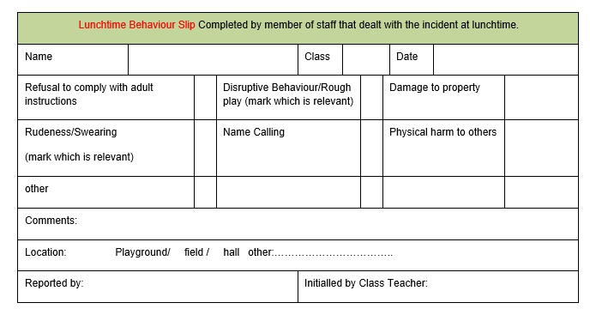

Please add enough detail to reduce the need for any conversation.

The class teacher will carry out the coaching session during the pupil’s free time however this will be followed with a repair session to allow the child to understand how their behaviour impacted on others.

Appendix II
Name of child:………………………………………………………………………….
Class:………………………..

Dear ……………………….,
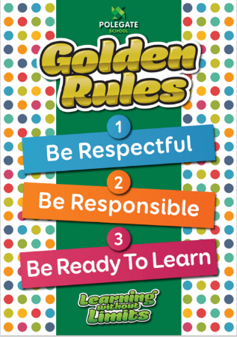
I am writing to express our concern that……………………………………………………….has had three or more incidents in which they have not met our school expectations:
We have been supporting them with coaching but the behaviour continues as a result we would like to involve you, as their parent to discuss this in more depth and gain your views on a plan to support your child. Where the children’s behaviour is concerned we see this is as a shared responsibility between home and school and aim to establish mutually supportive partnerships.
We would like to involve you in this discussion and the support process to follow.
At Polegate School children are expected to behave well and work hard. We believe that a child needs to feel secure in order to achieve work of a high quality. If a child is unable to achieve the above, then we recognise this as a difficulty and will strive to support them. We will seek to understand why a child is behaving in the way they are.
I would like to invite you to discuss this on……………………………………………..
Please confirm your attendance.
Thank you for your support.
Yours Sincerely
Class teacher
--------------------------------------------------------------------------------------------------------------------------------------- Please return this slip to the class teacher:
I have received the letter about my child’s behaviour and will attend the meeting.
Signed:………………………………………………………………date:…………………………………..

Name of child:…………………………………………………….class………..
Appendix III
Behaviour Categories
We record incident to track patterns and trends and ensure we intervene early.

Type
Any behaviour recorded will have been wilfully carried out and do not meet our school expectations of

respect, ready and responsible
Refusal to work
Not following adult direction or instruction
Leaving class without permission
Disrupting learning of others
Abusive or insulting language
Theft
Racist insults
Homophobic language
Inappropriate sexualised behaviour
Record on Myconcern as well
Injuring another member of school community
Staff and pupils
Damaging property or intent to damage property
Extreme dysregulated behaviour incident
Big incidents that are few and far between
Likely to be used for children already identified with a high level of SEND need, attachment, ACES

Appendix III
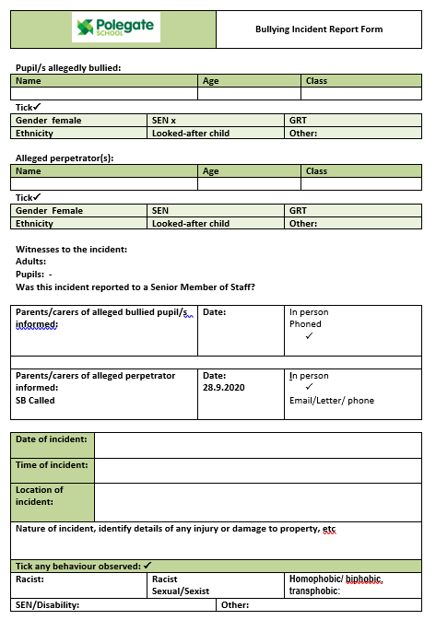
Bullying Incident Report

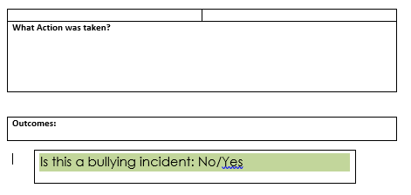

Appendix V
All parent alert slips are saved on the staff drive
Reading Alert
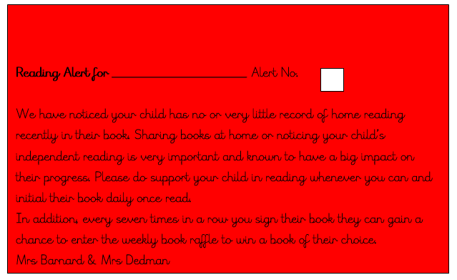

PE uniform
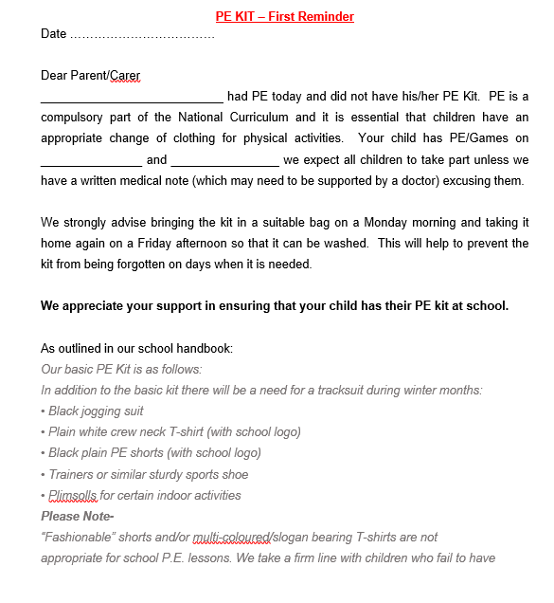
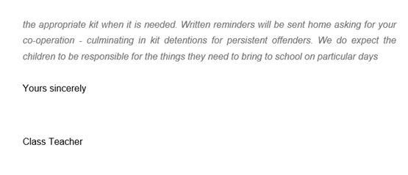

Uniform Alert Letter
