Polegate School

Maths Calculation Policy

Addition
Year 1 | Year 2 |  | Year 3
Expected | Expected |  | Expected
- read, write and interpret mathematical statements involving addition (+), subtraction (−) and equals (=) signs  - represent and use number bonds and related subtraction facts within 20  - add and subtract one-digit and two-digit numbers to 20, including 0  - Solve one-step problems that involve addition and subtraction, using concrete objects and pictorial representations, and missing number problems such as 7 = ? − 9 | - solve problems with addition and subtraction:  - using concrete objects and pictorial representations, including those involving numbers, quantities and measures  - applying their increasing knowledge of mental and written methods  - recall and use addition and subtraction facts to 20 fluently, and derive and use related facts up to 100  - add and subtract numbers using concrete objects, pictorial representations, and mentally, including:  - a two-digit number and 1s  - a two-digit number and 10s  - 2 two-digit numbers  - adding 3 one-digit numbers  - show that addition of 2 numbers can be done in any order (commutative) and subtraction of 1 number from another cannot  - recognise and use the inverse relationship between addition and subtraction and use this to check calculations and solve missing number problems |  | - add and subtract numbers mentally, including:  a three-digit number and 1s  a three-digit number and 10s  a three-digit number and 100s  - add and subtract numbers with up to 3 digits, using formal written methods of columnar addition and subtraction  - estimate the answer to a calculation and use inverse operations to check answers  - solve problems, including missing number problems, using number facts, place value, and more complex addition and subtraction
In-depth | In-depth |  | In-depth
- memorise and reason with number bonds to 10 and 20 in several forms (for example, 9 + 7 = 16; 16 − 7 = 9; 7 = 16 − 9).  - realise the effect of adding or subtracting 0.  - establish addition and subtraction as related operations.  - combine and increase numbers, counting forwards and backwards.  - discuss and solve problems in familiar practical contexts, including using quantities.  - Problems should include the terms: put together, add, altogether, total, take away, distance between, difference between, more than and less than, so that pupils develop the concept of addition and subtraction and are enabled to use these operations flexibly. | - extend their understanding of the language of addition and subtraction to include sum and difference.  - practise addition and subtraction to 20 is fluent in deriving facts such as using 13 + 7 = 20; 20 − 17 = 3 and 20 = 17 + 3 to calculate 30 + 70 = 100; 100 − 70 = 30 and 70 = 100 − 30.  - check their calculations, including by adding to check subtraction and adding numbers in a different order to check addition (for example, 5 + 2 + 1 = 1 + 5 + 2 = 1 + 2 + 5). This establishes commutativity and associativity of addition.  - record addition and subtraction in columns supports place value and prepares for formal written methods with larger numbers.  - 14 + __ = 15 + 27 Use the inverse to work out difficult problems. | - practise solving varied addition and subtraction questions.  - for mental calculations with two-digit numbers, the answers could exceed 100.  use their understanding of place value and partitioning, and practise using columnar addition and subtraction with increasingly large numbers up to 3 digits to become fluent

Reception to Year 1 – CPA Approach: Addition
Objective and Strategy | Concrete | Pictorial | Abstract
Reception  Addition & subtraction | 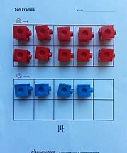  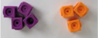  The children will start to use five frames and then build up to 10 frames. | 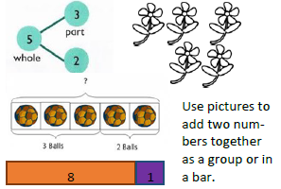 | 8 + 1 = 9  9 – 1 = 8
Reception  Combining two parts to make a whole part: part-whole model. | 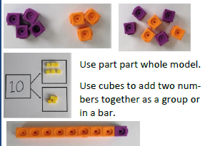 |  | 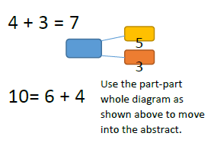
Counting on using number lines. | 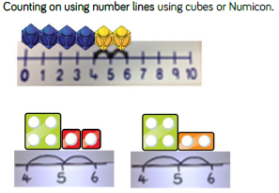 | 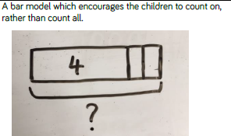 | 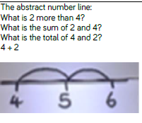
Regrouping to make 10 | 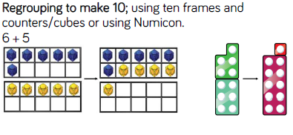 | 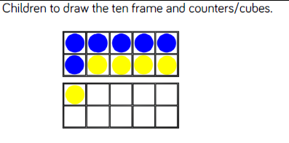 | 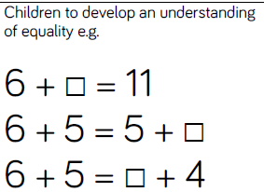

Year 2 - CPA Approach: Addition

Objective and Strategy | Concrete | Pictorial | Abstract
Use known facts: part, part whole. | 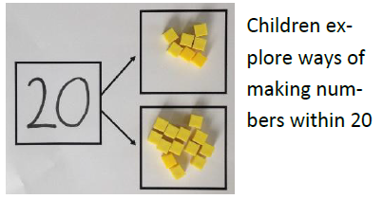 | 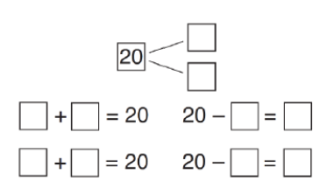 | 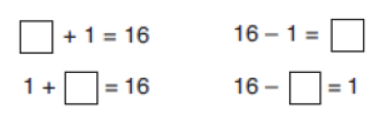
Adding multiples of ten | 30 + 20 = 50 50 = 20 + 30 | 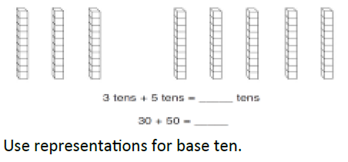 | 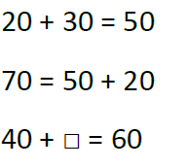
Adding multiplies of ten:  Use known facts | 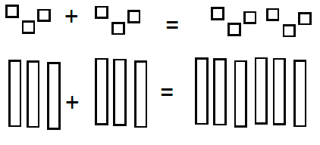 | 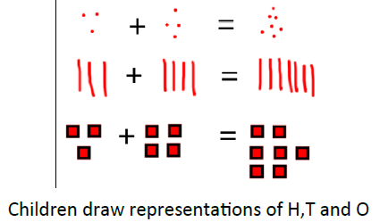 | 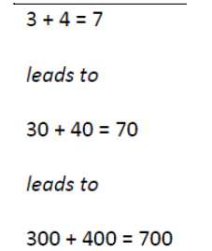
Adding multiples of ten: Bar model | 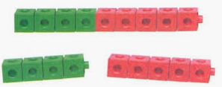 | 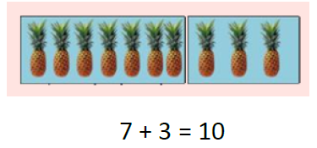 | 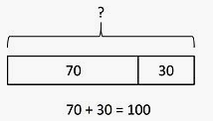

Year 2 - CPA Approach: Addition

Objective and strategy | Concrete | Pictorial | Abstract
Add a two digit number and tens. | 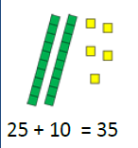  Explore why the ones digit doesn’t change. | 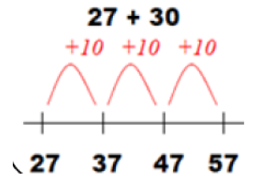  Differentiation: either use real numbers lines or children to draw their own empty number lines. | 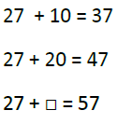
Add a two digit number and ones.  The ‘making ten first’ strategy. | 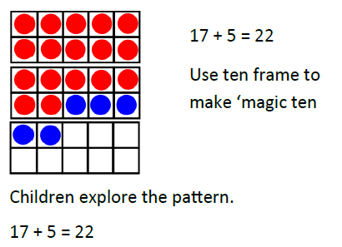 | 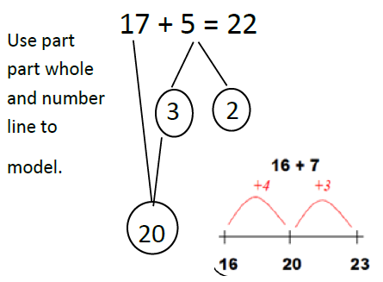 | 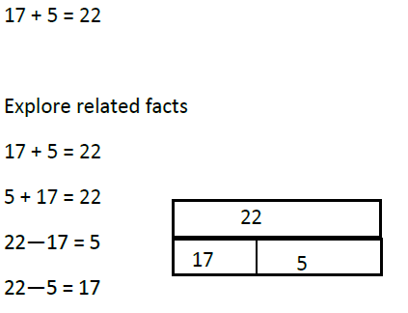
Add a two 2 digit numbers. | 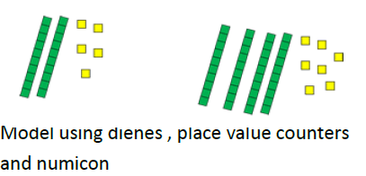 | 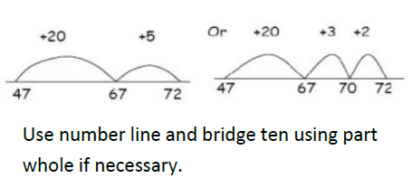 | 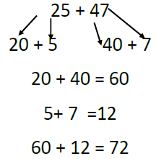
Add a two 2 digit numbers. | 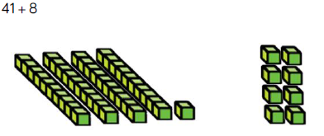 | 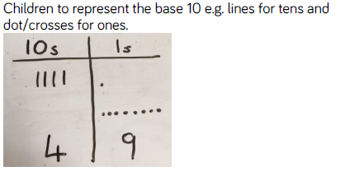 | Use the formal method only if children are secure with their mental strategies.  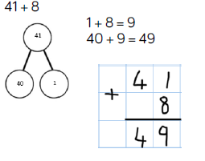
Continue to develop partitioning and place value: TO + TO | 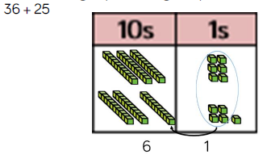 | 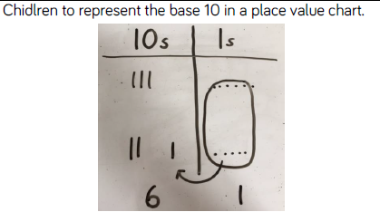 | 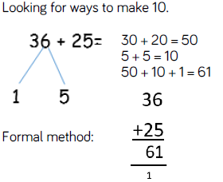  Only move onto the formal method if children are secure with their mental strategies of adding TO + TO.

Year 3 – CPA Approach: Addition

Objective and strategy | Concrete | Pictorial | Abstract
Add numbers up to 3 digits using a formal written method  Column Addition – No regrouping | 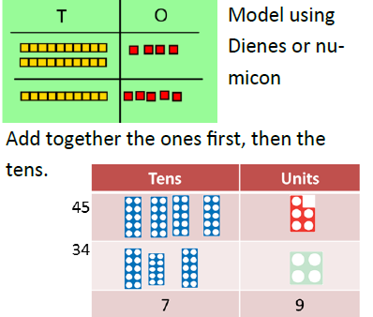 | 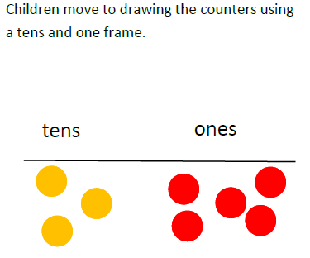 | 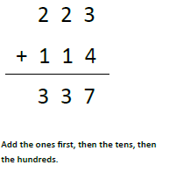
Add numbers up to 3 digits using a formal written method  Column Addition – Regrouping | 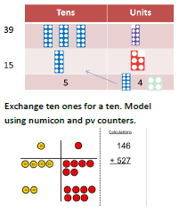 | 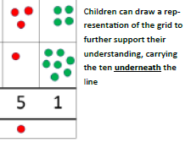 | 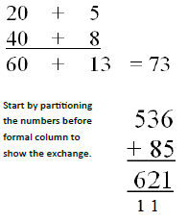
Add numbers up to 3 digits using a formal written method | 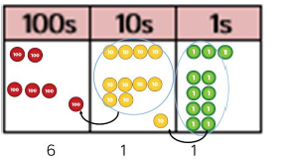 | 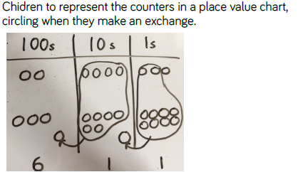 | 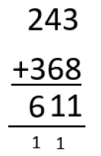

Addition
Year 4 | Year 5 | Year 6
Expected | Expected | Expected
- add and subtract numbers with up to 4 digits using the formal written methods of columnar addition and subtraction where appropriate  - estimate and use inverse operations to check answers to a calculation  - solve addition and subtraction two-step problems in contexts, deciding which operations and methods to use and why  - round decimals with one decimal place to the nearest whole number  - compare numbers with the same number of decimal places up to two decimal places  - solve simple measure and money problems involving fractions and decimals to two decimal places. | - add and subtract whole numbers with more than 4 digits, including using formal written methods (columnar addition and subtraction)  - add and subtract numbers mentally with increasingly large numbers  - use rounding to check answers to calculations and determine, in the context of a problem, accuracy  - solve addition and subtraction multi-step problems in contexts, deciding which operations and methods to use and why  - solve problems involving number up to three decimal places  - recognise the per cent symbol (%) and understand that per cent relates to ‘number of parts per hundred’, and write percentages as a fraction with denominator 100, and as a decimal  - solve problems which require knowing percentage and decimal equivalents of ½, ¼, 1/5,2/5, 4/5 and those fractions with a denominator of a multiple of 10 or 25. | - perform mental calculations, including with mixed operations and large numbers  - identify common factors, common multiples and prime numbers  - use their knowledge of the order of operations to carry out calculations involving the 4 operations  - solve addition and subtraction multi-step problems in contexts, deciding which operations and methods to use and why  - solve problems involving addition, subtraction, multiplication and division  - use estimation to check answers to calculations and determine, in the context of a problem, an appropriate degree of accuracy  - solve problems which require answers to be rounded to specified degrees of accuracy
In-depth | In-depth | In-depth
- continue to practise both mental methods and columnar addition and subtraction with increasingly large numbers to aid fluency | - practise using the formal written methods of  - columnar addition with increasingly large numbers to aid fluency.  - practise mental calculations with increasingly large numbers, e.g., 12,462 – 2,300 = 10,162).  - introduce the language of algebra as a means of solving a variety of problems  - mentally add and subtract tenths, and one-digit whole numbers and tenths.  - practise adding and subtracting decimals, including a mix of whole numbers and decimals, with different numbers of decimal places, and complements of 1 (for example, 0.83 + 0.17 = 1).  - Pupils should go beyond the measurement and money models of decimals to solving puzzle | - practise addition for larger numbers, using the formal written methods of columnar addition  - undertake mental calculations with increasingly large numbers and more complex calculations.  - round answers to a specified degree of accuracy, for example, to the nearest 10, 20, 50, etc, but not to a specified number of significant figures.  - explore the order of operations using brackets; for example, 2 + 1 x 3 = 5 and (2 + 1) x 3 = 9.  - Understand common factors can be related to finding equivalent fractions  - develop the language of algebra as a means of solving a variety of problems

Year 4 - CPA

Objective and strategy | Concrete | Pictorial | Abstract
Add numbers with up to 4 digits using the formal written methods of column addition. | Children continue to use dienes or place value counters to add, exchanging tens ones for a ten and ten tens for a hundred and ten hundreds for a thousand.  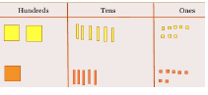 | 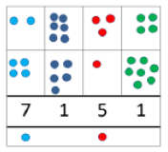 | 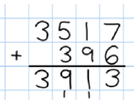  Continue from previous work to carry hundreds as well as tens. Relate to money and measures.

Year 5 & 6 - CPA

Objective and strategy | Concrete | Pictorial | Abstract
Year 5  Add numbers with more than 4 digits.  Add decimals with 2 decimals places, including money. | 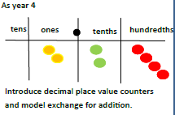 | 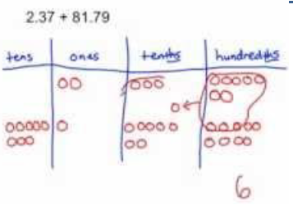 | 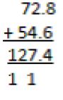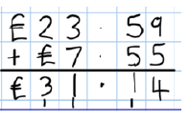
Year 6  Add numbers of increasing complexity  Including adding money, measure and decimals with different numbers of decimal points. |  |  | 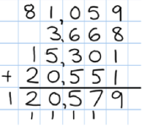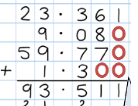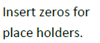

Subtraction
Year 1 | Year 2 | Year 3
Expected | Expected | Expected
- count to and across 100, forwards and backwards, beginning with 0 or 1, or from any given number  - given a number, identify 1 more and 1 less  identify and represent numbers using objects and pictorial representations including the number line, and use the language of: equal to, more than, less than (fewer), most, least | - solve problems with addition and subtraction:  - using concrete objects and pictorial representations, including those involving numbers, quantities and measures  - applying their increasing knowledge of mental and written methods  - recall and use addition and subtraction facts to 20 fluently, and derive and use related facts up to 100  - add and subtract numbers using concrete objects, pictorial representations, and mentally, including:  - a two-digit number and 1s  - a two-digit number and 10s  - 2 two-digit numbers  - adding 3 one-digit numbers  - show that addition of 2 numbers can be done in any order (commutative) and subtraction of 1 number from another cannot  recognise and use the inverse relationship between addition and subtraction and use this to check calculations and solve missing number problems | - add and subtract numbers mentally, including:  a three-digit number and 1s  three-digit number and 10s  a three-digit number and 100s  - add and subtract numbers with up to 3 digits, using formal written methods of columnar addition and subtraction  - estimate the answer to a calculation and use inverse operations to check answers  - solve problems, including missing number problems, using number facts, place value, and more complex addition and subtraction
In-depth | In-depth | In-depth
- memorise and reason with number bonds to 10 and 20 in several forms (for example, 9 + 7 = 16; 16 − 7 = 9; 7 = 16 − 9).  - realise the effect of adding or subtracting 0. This establishes addition and subtraction as related operations.  - combine and increase numbers, counting forwards and backwards.  - discuss and solve problems in familiar practical contexts, including using quantities.  problems should include the terms: put together, add, altogether, total, take away, distance between, difference between, more than and less than, so that pupils develop the concept of addition and subtraction and are enabled to use these operations flexibly. | - extend their understanding of the language of addition and subtraction to include sum and difference.  - practise addition and subtraction to 20 to become increasingly fluent in deriving facts such as using 3 + 7 = 10; 10 − 7 = 3 and 7 = 10 − 3 to calculate 30 + 70 = 100; 100 − 70 = 30 and 70 = 100 − 30.  - check their calculations, including by adding to check subtraction and adding numbers in a different order to check addition (for example, 5 + 2 + 1 = 1 + 5 + 2 = 1 + 2 + 5). This establishes commutativity and associativity of addition.  - record addition and subtraction in columns supports place value and prepares for formal written methods with larger numbers | - practise solving varied addition and subtraction questions.  - mental calculations with two-digit numbers, the answers could exceed 100.  - use their understanding of place value and partitioning, and practise using columnar addition and subtraction with increasingly large numbers up to 3 digits to become fluent  - develop the language of algebra as a means of solving a variety of problems

Subtraction
Year 4 | Year 5 | Year 6
Expected | Expected | Expected
- add and subtract numbers with up to 4 digits using the formal written methods of columnar addition and subtraction where appropriate  - estimate and use inverse operations to check answers to a calculation  - solve addition and subtraction two-step problems in contexts, deciding which operations and methods to use and why  - solve simple measure and money problems involving fractions and decimals to two decimal places. | - add and subtract whole numbers with more than 4 digits, including using formal written methods (columnar addition and subtraction)  - add and subtract numbers mentally with increasingly large numbers  - use rounding to check answers to calculations and determine, in the context of a problem, levels of accuracy  - solve addition and subtraction multi-step problems in contexts, deciding which operations and methods to use and why | - use their knowledge of the order of operations to carry out calculations involving the 4 operations  - solve addition and subtraction multi-step problems in contexts, deciding which operations and methods to use and why  - solve problems involving addition, subtraction, multiplication and division  - use estimation to check answers to calculations and determine, in the context of a problem, an appropriate degree of accuracy  - perform mental calculations, including with mixed operations and large numbers  - solve problems which require answers to be rounded to specified degrees of accuracy
In-depth | In-depth | In-depth
- continue to practise both mental methods and columnar addition and subtraction with increasingly large numbers to aid fluency | - practise using the formal written methods of  - columnar subtraction with increasingly large numbers to aid fluency.  - practise mental calculations with increasingly large numbers to aid fluency (for example, 12,462 – 2,300 = 10,162).  - introduce the language of algebra as a means of solving a variety of problems  - mentally add and subtract tenths, and one-digit whole numbers and tenths.  - Solve difficult problems.  23 – 5 = 30 - ___ | - practise subtraction for larger numbers, using the formal written methods of columnar subtraction,  - undertake mental calculations with increasingly large numbers and more complex calculations.  - develop the language of algebra as a means of solving a variety of problems

Reception - Year 1 – CPA Approach: Subtraction

Objective & Strategy | Concrete | Pictorial | Abstract
Subtract a one digit number. | 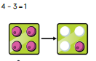  Physically taking away and removing objects from a whole. | 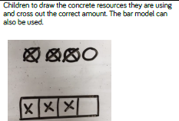 | 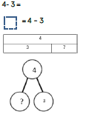
Counting back | 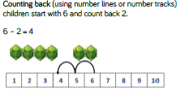 | 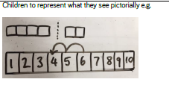 | 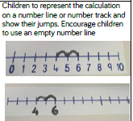
Bar model | 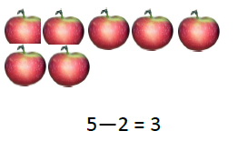 | 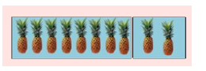 | 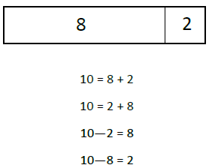
Find the difference | 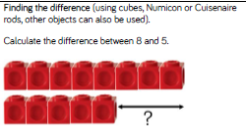 | 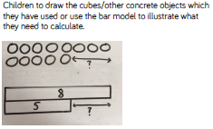 | 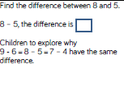
Subtraction using the ‘making 10’ strategy. | 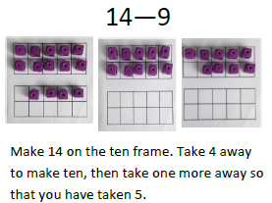 | 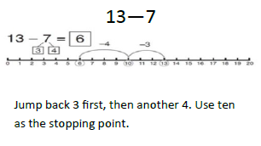 | 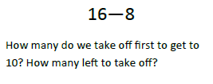

Year 2 – CPA Approach: Subtraction

Objective & Strategy | Concrete | Pictorial | Abstract
Subtracting using the ‘making ten first’ strategy. | 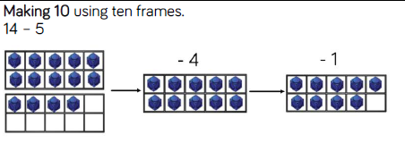 | 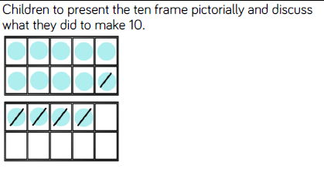 | 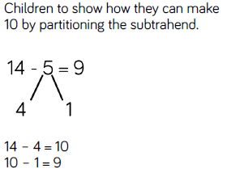
Regroup a ten into ten ones | 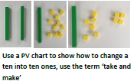 | 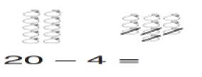 | 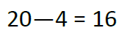
Partitioning to subtract without regrouping | 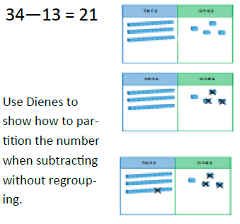 | 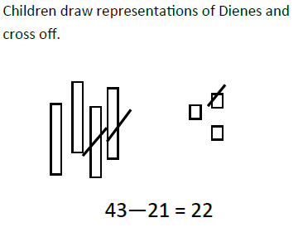 | 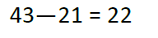

Year 2/3 – CPA Approach: Subtraction

Objective & Strategy | Concrete | Pictorial | Abstract
Subtract numbers including:  A two digit and ones  A two digit and tens  Two two digits | 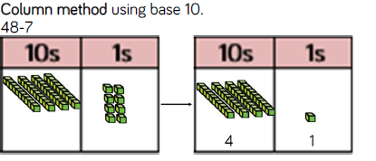 | 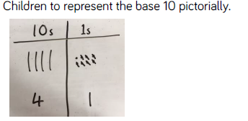 | 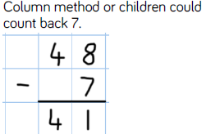

Year 3 – CPA Approach: Subtraction

Objective & Strategy | Concrete | Pictorial | Abstract
Subtract numbers with up to three digits using a formal written method.  Column subtraction - Regrouping | 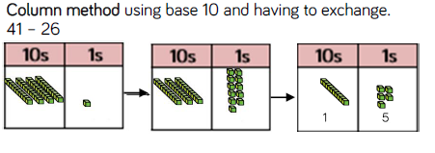 | 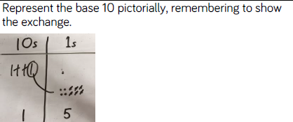 | 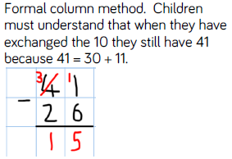
Subtract numbers with up to three digits using a formal written method.  Column subtraction – Regrouping | 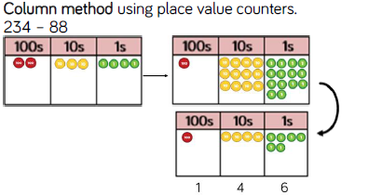 | 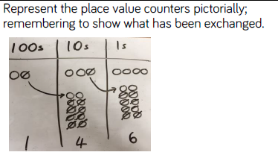 | 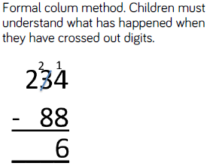

Year 4, 5 & 6 – CPA Approach: Subtraction

Objective & Strategy | Concrete | Pictorial | Abstract
Year 4  Subtract tens and ones.  Subtract up to 4 digits.  Introduce decimal subtraction through context of money. | 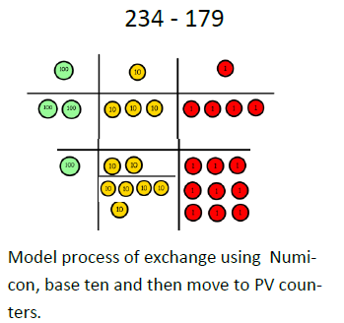 | Children to draw place value counters and show their regrouping – see Y3. | 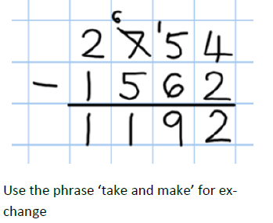
Year 5  Subtract with at least 4 digits, including money and measures.  Subtract with decimal values, including mixtures of integers and decimals and aligning the decimal. |  |  | 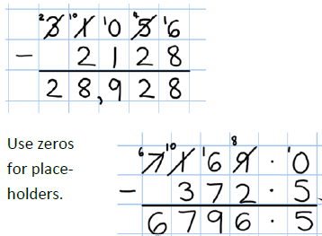
Year 6  Subtract with increasingly large and more complex numbers and decimal values. |  |  | 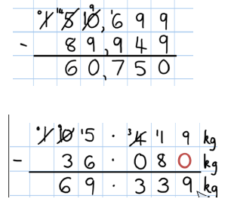

Multiplication
Year 1 | Year 2 | Year 3
Expected | Expected | Expected
- solve one-step problems involving multiplication and division, by calculating the answer using concrete objects, pictorial representations and arrays with the support of the teacher | - recall and use multiplication and division facts for the 2, 5 and 10 multiplication tables, including recognising odd and even numbers  - calculate mathematical statements for multiplication and division within the multiplication tables and write them using the multiplication (×), division (÷) and equals (=) signs  - show that multiplication of 2 numbers can be done in any order (commutative) and division of 1 number by another cannot  - solve problems involving multiplication and division, using materials, arrays, repeated addition, mental methods, and multiplication and division facts, including problems in contexts | - count from 0 in multiples of 4, 8, 50 and 100; find 10 or 100 more or less than a given number  - recognise the place value of each digit in a 3-digit number (100s, 10s, 1s)  - compare and order numbers up to 1,000  - identify, represent and estimate numbers using different representations  - read and write numbers up to 1,000 in numerals and in words  - solve number problems and practical problems involving these ideas
In-depth | In-depth | In-depth
- through grouping and sharing small quantities, pupils begin to understand:  multiplication and division;  doubling numbers and quantities;  finding simple fractions of objects,  numbers and quantities  - make connections between arrays, number patterns, and counting in twos, fives and tens. | - use a variety of language to describe multiplication and division  - introduce the multiplication tables.  - practise to become fluent in the 2, 5 and 10 multiplication tables and connect them to each other.  - connect the 10 multiplication table to place value, and the 5 multiplication table to the divisions on the clock face.  - begin to use other multiplication tables and recall multiplication facts, including using related division facts to perform written and mental calculations.  - Work with a range of materials and contexts in which multiplication and division relate to grouping and sharing discrete and continuous quantities, to arrays and to repeated addition.  - begin to relate these to fractions and measures (for example, 40 ÷ 2 = 20, 20 is a half of 40).  - use inverse relations to develop reasoning (for example, 4 × 5 = 20 and 20 ÷ 5 = 4). | - use multiples of 2, 3, 4, 5, 8, 10, 50 and 100.  - use larger numbers to at least 1,000, applying partitioning related to place value using varied and increasingly complex problems, building on work in year 2 (for example, 146 = 100 + 40 + 6, 146 = 130 +16).  - use a variety of representations, including those related to measure, pupils continue to count in 1s, 10s and 100s, so that they become fluent in the order and place value of numbers to 1,000.

Multiplication

Multiplication
Year 4 | Year 5 | Year 6
Expected | Expected | Expected
- recall multiplication and division facts for multiplication tables up to 12 × 12  - use place value, known and derived facts to multiply and divide mentally, including: multiplying by 0 and 1; dividing by 1; multiplying together 3 numbers  - recognise and use factor pairs and commutativity in mental calculations  - multiply two-digit and three-digit numbers by a one-digit number using formal written layout  - solve problems involving multiplying and adding, including using the distributive law to multiply two-digit numbers by 1 digit, integer scaling problems and harder correspondence problems such as n objects are connected to m objects  . | - identify multiples and factors, including finding all factor pairs of a number, and common factors of 2 numbers  - know and use the vocabulary of prime numbers, prime factors and composite (non-prime) numbers  - establish whether a number up to 100 is prime and recall prime numbers up to 19  - multiply numbers up to 4 digits by a one- or two-digit number using a formal written method, including long multiplication for two-digit numbers  - multiply and divide numbers mentally, drawing upon known facts  - multiply and divide whole numbers and those involving decimals by 10, 100 and 1,000  - recognise and use square numbers and cube numbers, and the notation for squared (²) and cubed (³)  - solve problems involving multiplication and division, including using their knowledge of factors and multiples, squares and cubes  - solve problems involving addition, subtraction, multiplication and division and a combination of these, including understanding the meaning of the equals sign  - solve problems involving multiplication and division, including scaling by simple fractions and problems involving simple rates | - multiply multi-digit numbers up to 4 digits by a two-digit whole number using the formal written method of long multiplication  - identify common factors, common multiples and prime numbers  - perform mental calculations, including with mixed operations and large numbers  - use their knowledge of the order of operations to carry out calculations involving the 4 operations  - solve problems involving addition, subtraction, multiplication and division  - use estimation to check answers to calculations and determine, in the context of a problem, an appropriate degree of accuracy  - identify the value of each digit in numbers given to three decimal places and multiply and divide numbers by 10, 100 and 1000 giving answers up to three decimal places  - multiply one-digit numbers with up to two decimal places by whole numbers  - solve problems which require answers to be rounded to specified degrees of accuracy  - recall and use equivalences between simple fractions, decimals and percentages, including in different contexts.  - solve problems which require answers to be rounded to specified degrees of accuracy
In-depth | In-depth | In-depth
- continue to practise recalling and using multiplication tables and related division facts to aid fluency.  - practise mental methods and extend this to 3-digit numbers to derive facts, (for example 600 ÷ 3 = 200 can be derived from 2 x 3 = 6).  - practise to become fluent in the formal written method of short multiplication and short division with exact answers  - write statements about the equality of expressions (for example, use the distributive law 39 × 7 = 30 × 7 + 9 × 7 and associative law (2 × 3) × 4 = 2 × (3 × 4)).  - combine their knowledge of number facts and rules of arithmetic to solve mental and written calculations for example, 2 x 6 x 5 = 10 x 6 = 60.  - solve two-step problems in contexts, choosing the appropriate operation, working with increasingly harder numbers. This should include correspondence questions such as the numbers of choices of a meal on a menu, or 3 cakes shared equally between 10 children | - practise and extend their use of the formal written methods of short multiplication and short division.  - apply all the multiplication tables and related division facts frequently, commit them to memory and use them confidently to make larger calculations.  - use and understand the terms factor, multiple and prime, square and cube numbers.  - interpret non-integer answers to division by expressing results in different ways according to the context, including with remainders, as fractions, as decimals or by rounding (for example, 98 ÷ 4 = 98/4 = 24 r 2 = 241/2 = 24.5 ≈ 25).  - use multiplication and division as inverses to support the introduction of ratio in year 6, for example, by multiplying and dividing by powers of 10 in scale drawings or by multiplying and dividing by powers of a 1,000 in converting between units such as kilometres and metres.  - introduce the language of algebra as a means of solving a variety of problems  - distributivity can be expressed as a(b + c) = ab + ac.  - understand the terms factor, multiple and prime, square and cube numbers and use them to construct equivalence statements (for example, 4 x 35 = 2 x 2 x 35; 3 x 270 = 3 x 3 x 9 x 10 = 9² x 10).  - use and explain the equals sign to indicate equivalence, including in missing number problems (for example 13 + 24 = 12 + 25; 33 = 5 x ?). | - practise multiplication for larger numbers, using the formal written methods of short and long multiplication.  - undertake mental calculations with increasingly large numbers and more complex calculations.  - continue to use all the multiplication tables to calculate mathematical statements in order to maintain their fluency.  - explore the order of operations using brackets; for example, 2 + 1 x 3 = 5 and (2 + 1) x 3 = 9.  - understand common factors can be related to finding equivalent fractions  - develop the connection made between multiplication and division with fractions, decimals, percentages and ratio  - develop the language of algebra as a means of solving a variety of problems  - multiply and divide numbers with up to two decimal places by one-digit and two-digit whole numbers.  - multiply decimals by whole numbers, starting with the simplest cases, such as 0.4 × 2 = 0.8, and in practical contexts, such as measures and money.

Reception - Year 1 – CPA Approach: Multiplication

Objective & Strategy | Concrete | Pictorial | Abstract
Doubling | 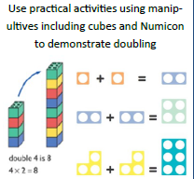 | 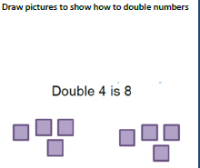 | 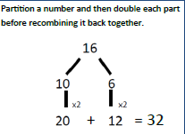
Counting in multiples | 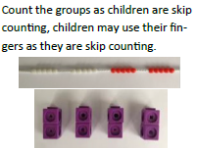 | 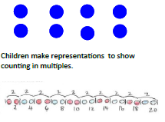 | 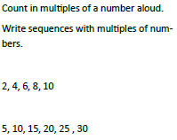
Making equal groups and counting the total. | 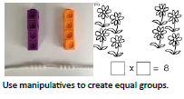 | 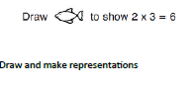
Repeated addition | 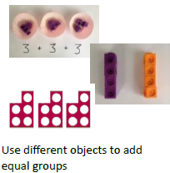 | 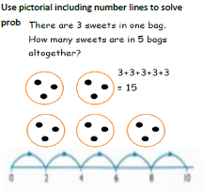 | 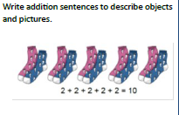
Understanding arrays | 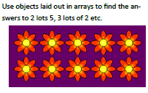 | 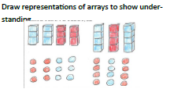 | 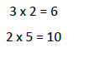

Year 2 – CPA Approach: Multiplication

Objective & Strategy | Concrete | Pictorial | Abstract
Doubling | 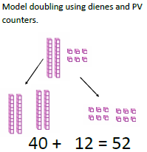 |  | 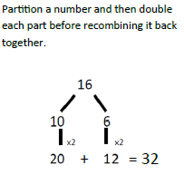
Counting in multiples of 2, 3, 4, 5, 10 from 0.  (Repeated addition) | 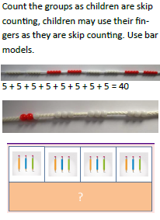 | 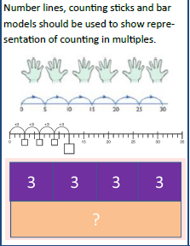 | 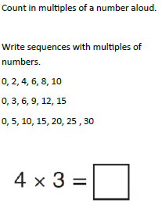
Multiplication is commutative. | 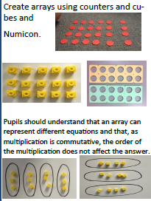 | 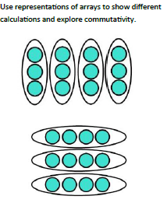 | 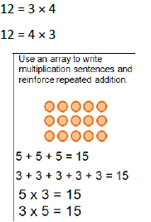
Using the Inverse.  This should be taught alongside division, so pupils learn how they work alongside each other. | 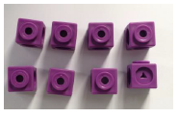 | 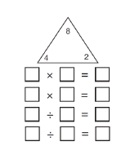 | 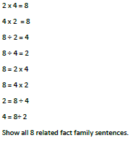

Year 3 – CPA Approach: Multiplication

Objective & Strategy | Concrete | Pictorial | Abstract
Repeated grouping/  Repeated addition | 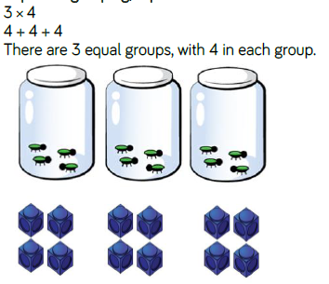 | 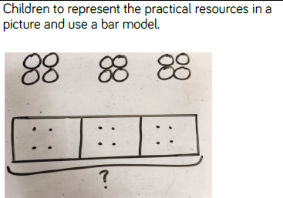 | 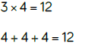
Repeated grouping/  Repeated addition | 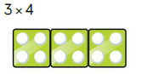 | 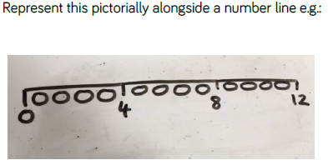 | 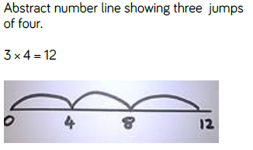
Use arrays to illustrate commutativity. | 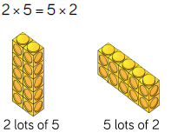 | 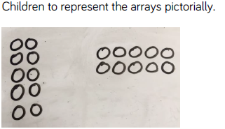 | 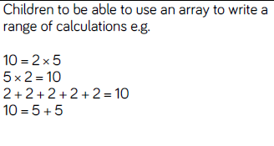
Grid method | 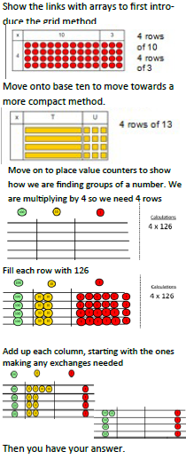 | 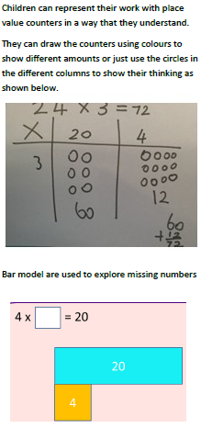 | 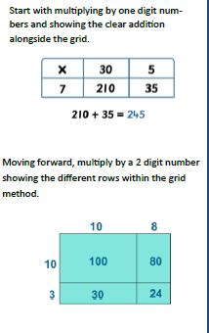

Year 4 – CPA Approach: Multiplication

Objective & Strategy | Concrete | Pictorial | Abstract
Partition to multiply. | 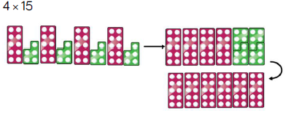 | 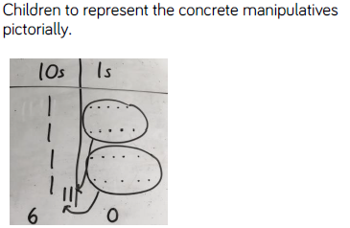 | 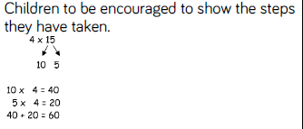
Multiply a two-digit & three-digit numbers by a one digit number using a formal method. | 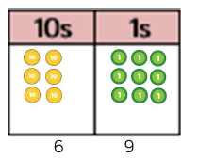 | 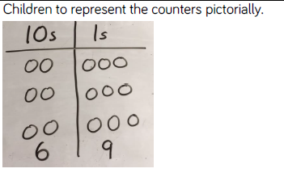 | 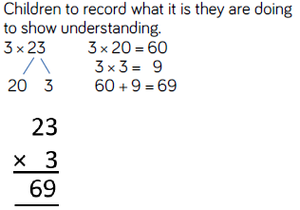
 | 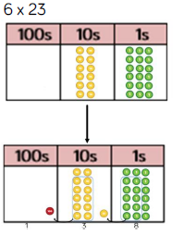 | 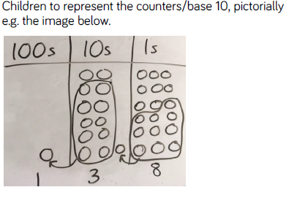 | 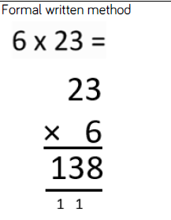

Year 5 & 6 – CPA Approach: Multiplication

Objective & Strategy | Concrete | Pictorial | Abstract
Column multiplication for 3 and 4 digit numbers x 1 digit. | 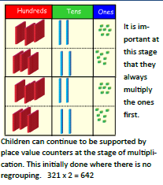 | 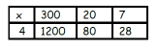 | 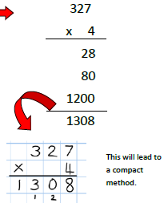
Column multplication | 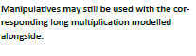 | 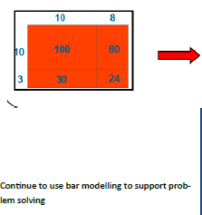 | 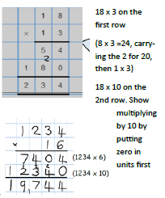
Year 6  Multiplying decimals up to 2 decimal places by a single digit. |  |  | 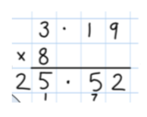

Division
Year 1 | Year 2 | Year 3
Expected | Expected | Expected
- solve one-step problems involving multiplication and division, by calculating the answer using concrete objects, pictorial representations and arrays with the support of the teacher | - recall and use multiplication and division facts for the 2, 5 and 10 multiplication tables, including recognising odd and even numbers  - calculate mathematical statements for multiplication and division within the multiplication tables and write them using the multiplication (×), division (÷) and equals (=) signs  - show that multiplication of 2 numbers can be done in any order (commutative) and division of 1 number by another cannot  - solve problems involving multiplication and division, using materials, arrays, repeated addition, mental methods, and multiplication and division facts, including problems in contexts | - divide numbers up to 4 digits by a two-digit whole number using the formal written method of long division, and interpret remainders as whole number remainders, fractions, or by rounding, as appropriate for the context  - divide numbers up to 4 digits by a two-digit number using the formal written method of short division where appropriate, interpreting remainders according to the context
In-depth | In-depth | In-depth
- through grouping and sharing small quantities, pupils begin to understand:  multiplication and division;  doubling numbers and quantities;  finding simple fractions of objects,  numbers and quantities  - make connections between arrays, number patterns, and counting in twos, fives and tens. | - use a variety of language to describe multiplication and division.  - begin to use other multiplication tables and recall multiplication facts, including using related division facts to perform written and mental calculations.  - work with a range of materials and contexts in which multiplication and division relate to grouping and sharing discrete and continuous quantities, to arrays and to repeated addition.  - begin to relate these to fractions and measures (for example, 40 ÷ 2 = 20, 20 is a half of 40).  - use commutativity and inverse relations to develop multiplicative reasoning (for example, 4 × 5 = 20 and 20 ÷ 5 = 4). | - develop efficient mental methods, for example, using commutativity and associativity (for example, 4 × 12 × 5 = 4 × 5 × 12 = 20 × 12 = 240) and multiplication and division facts (eg, using 3 × 2 = 6, 6 ÷ 3 = 2 and 2 = 6 ÷ 3) to derive related facts (eg, 30 × 2 = 60, 60 ÷ 3 = 20 and 20 = 60 ÷ 3).  - develop reliable written methods for multiplication and division, starting with calculations of two-digit numbers by one-digit numbers and progressing to the formal written methods of short multiplication and division.  - solve simple problems in contexts, deciding which of the four operations to use and why. Include measuring and scaling contexts, (for example, four times as high, eight times as long etc.) and correspondence problems in which m objects are connected to n objects (eg, 3 hats and 4 coats, how many different outfits?; 12 sweets shared equally between 4 children;  - 4 cakes shared equally between 8 children).  Key language – dividend (27) divided by the divisor (9) that will equal the quotient (3)

Division
Year 4 | Year 5 | Year 6
Expected | Expected | Expected
- recall multiplication and division facts for multiplication tables up to 12 × 12  - use place value, known and derived facts to multiply and divide mentally, including: multiplying by 0 and 1; dividing by 1; multiplying together 3 numbers  - recognise and use factor pairs and commutativity in mental calculations  - find the effect of dividing a one- or two-digit number by 10 and 100, identifying the value of the digits in the answer as ones, tenths and hundredths | - identify multiples and factors, including finding all factor pairs of a number, and common factors of 2 numbers  - multiply and divide numbers mentally, drawing upon known facts  - divide numbers up to 4 digits by a one-digit number using the formal written method of short division and interpret remainders appropriately for the context  - multiply and divide whole numbers and those involving decimals by 10, 100 and 1,000  - recognise and use square numbers and cube numbers, and the notation for squared (²) and cubed (³)  - solve problems involving multiplication and division, including using their knowledge of factors and multiples, squares and cubes  - solve problems involving addition, subtraction, multiplication and division and a combination of these, including understanding the meaning of the equals sign  - solve problems involving multiplication and division, including scaling by simple fractions and problems involving simple rate | - divide numbers up to 4 digits by a two-digit whole number using the formal written method of long division, and interpret remainders as whole number remainders, fractions, or by rounding, as appropriate for the context  - divide numbers up to 4 digits by a two-digit number using the formal written method of short division where appropriate, interpreting remainders according to the context  - use their knowledge of the order of operations to carry out calculations involving the 4 operations  - solve problems involving addition, subtraction, multiplication and division  - use estimation to check answers to calculations and determine, in the context of a problem, an appropriate degree of accuracy  - associate a fraction with division and calculate decimal fraction equivalents [for example, 0.375] for a simple fraction [for example, 3/8 ]  - identify the value of each digit in numbers given to three decimal places and multiply and divide numbers by 10, 100 and 1000 giving answers up to three decimal places  - use written division methods in cases where the answer has up to two decimal places  - solve problems which require answers to be rounded to specified degrees of accuracy
In-depth | In-depth | In-depth
- continue to practise recalling and using multiplication tables and related division facts to aid fluency.  - practise mental methods and extend this to 3-digit numbers to derive facts, (for example 600 ÷ 3 = 200 can be derived from 2 x 3 = 6).  - practise to become fluent in the formal written method of short multiplication and short division with exact answers  - solve two-step problems in contexts, choosing the appropriate operation, working with increasingly harder numbers. This should include correspondence questions such as the numbers of choices of a meal on a menu, or 3 cakes shared equally between 10 children  Key language – dividend (27) divided by the divisor (9) that will equal the quotient (3) | - practise and extend their use of the formal written methods of short multiplication and short division.  - apply all the multiplication tables and related division facts frequently, commit them to memory and use them confidently to make larger calculations.  - use and understand the terms factor, multiple and prime, square and cube numbers.  - interpret non-integer answers to division by expressing results in different ways according to the context, including with remainders, as fractions, as decimals or by rounding (for example,  98 ÷ 4 = ⁹⁸/⁴ = 24 r 2 = 24½ = 24.5 ≈ 25).  - use multiplication and division as inverses to support the introduction of ratio in year 6, for example, by multiplying and dividing by powers of 10 in scale drawings or by multiplying and dividing by powers of a 1,000 in converting between units such as kilometres and metres.  - distributivity can be expressed as  a(b + c) = ab + ac.  - use and explain the equals sign to indicate equivalence, including in missing number problems (for example 13 + 24 = 12 + 25; 33 = 5 x ?).  Key language – dividend (27) divided by the divisor (9) that will equal the quotient (3) | - practise division for larger numbers, using the formal written methods of short and long division  - explore the order of operations using brackets; for example, 2 + 1 x 3 = 5 and (2 + 1) x 3 = 9.  - Understand common factors can be related to finding equivalent fractions  - develop the connection made between multiplication and division with fractions, decimals, percentages and ratio  - explore and make conjectures about converting a simple fraction to a decimal fraction (for example, 3 ÷ 8 = 0.375).  - For simple fractions with recurring decimal equivalents, pupils learn about rounding the decimal to three decimal places, or other appropriate approximations depending on the context.  - introduce to the division of decimal numbers by one-digit whole number, initially, in practical contexts involving measures and money.  - recognise division calculations as the inverse of multiplication.  - develop the skills of rounding and estimating as a means of predicting and checking the order of magnitude of their answers to decimal calculations, including rounding answers to a specified degree of accuracy and checking the reasonableness of their answers.

Year 1 & Y2 – CPA Approach: Division

Objective & Strategy | Concrete | Pictorial | Abstract
Year 1  Division as sharing | 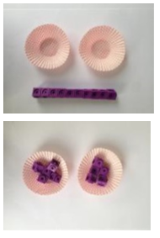  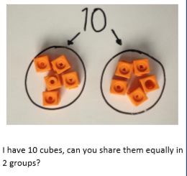 | 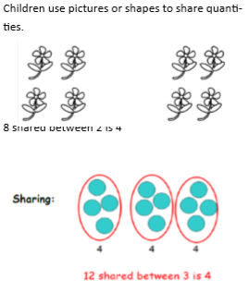 | 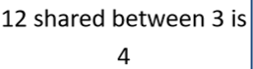
Year 2  Division as sharing | 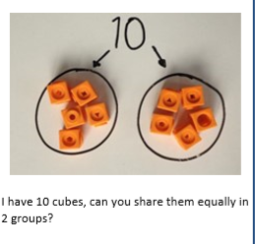 | 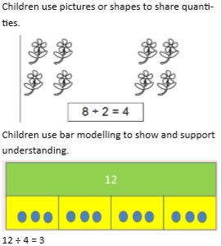 | 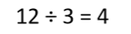
Division as grouping | 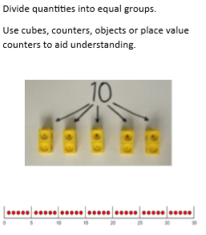 | 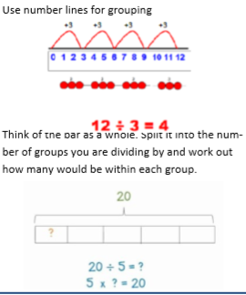 | 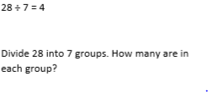

Year 3 – CPA Approach: Division

Objective & Strategy | Concrete | Pictorial | Abstract
Division as grouping | 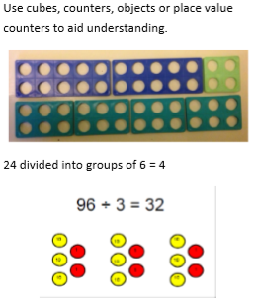 | 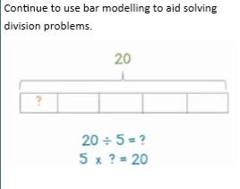 | 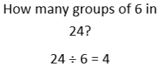
Division with arrays | 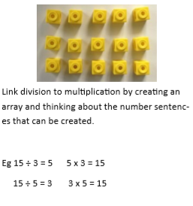 | 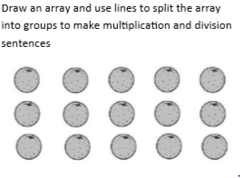 | 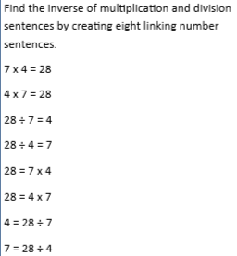
Division with remainders. | 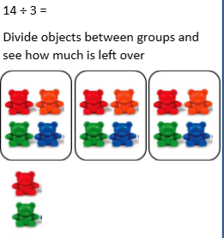 | 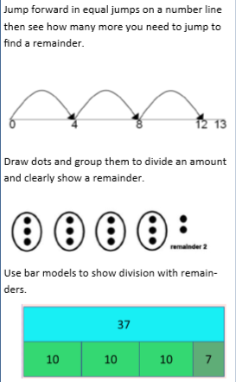 | 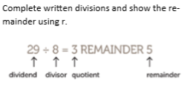

Year 4 & 5– CPA Approach: Division

Objective & Strategy | Concrete | Pictorial | Abstract
Divide at least 3 digit numbers by 1 digit.  Short division | 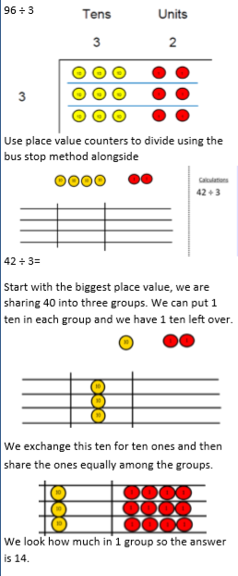 | 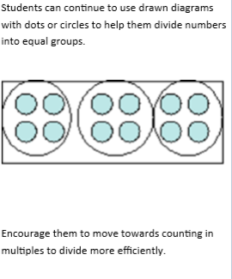 | 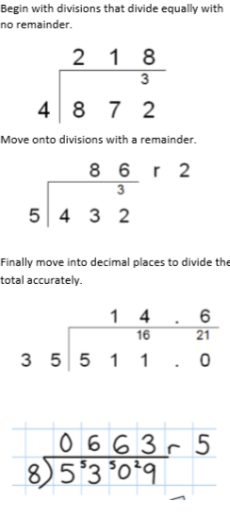

Year 6 – Long division

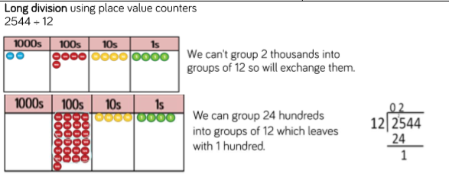
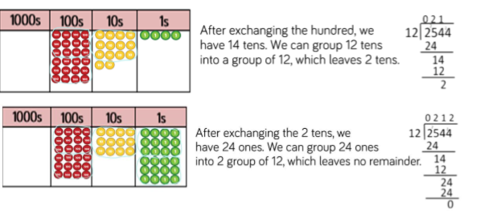
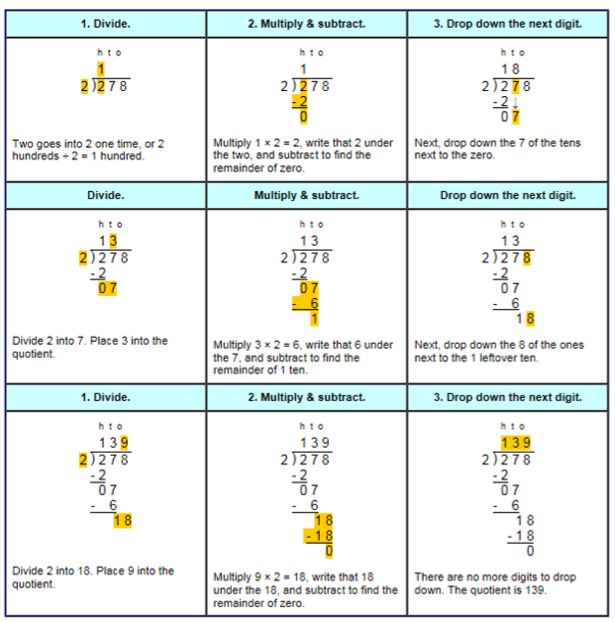

Fraction Policy
Stage | National Curriculum | Vocabulary + Strategies  Image
Year 1 | N/C: recognise, find and name a half as one of two equal parts of an object, shape or quantity.  N/C: recognise, find and name a quarter as one of four equal parts of an object, shape or quantity.  LO - I can name and find ¼ and ½ of a shape, an object or a quantity of objects | Shading fractions of shape  Shade 1/2 of this shape yellow.  1/2 1/2  Shade 1/4 of this shape yellow  1/4 1/4 1/4 1/4
Year 2 | N/C: recognise, find, name and write fractions 1/3, 1/4, 2/4 and3/4 of a length, shape, set of objects or quantity.  LO - I can find and name ¹/₃, ¹/₄ , ²/₄, and ³/₄ of a length, shape, set of objects or quantity  Greater Depth –  Find and compare fractions of amounts (e.g 14 of £20 = £5 and ½ of £8 = £4 so ¼ of £20 is greater than ½ of £8). | Shading fractions of shape  Shade 1/3 of this shape yellow.  Shade 1/4 of this shape yellow  Shade 2/4 of this shape yellow  Shade 3/4 of this shape yellow
Year 2 | N/C: write simple fractions e.g. 1/2 of 6 = 3 and recognise the equivalence of two quarters and one half.  LO - I can write simple fractions e.g. ¹/₂ of 6 = 3 and recognise the equivalence of two quarters and one half. | Recognising simple fractions  What’s a half of 6?  6  3 3  Thought Process:  For a half, divide the whole number by 2.  Recognising the equivalence of two quarters and one half  1/2  2/4  2/4 is equivalent to ½ using Numicon
Year 3 | N/C: count up and down in tenths; recognise that tenths arise from dividing an object into 10 equal parts and in dividing one-digit numbers or quantities by 10  LO - I can count up and down in tenths.  LO - I can show that tenths that arise from dividing a single digit number or a quantity by 10 are represented by a decimal number | Place value in decimal numbers  0.6 & 6/10 looks like:  0 0.1 0.2 0.3 0.4 0.5 0.6 0.7 0.8 0.9 1  0.7 & 7/10 looks like:  0 0.1 0.2 0.3 0.4 0.5 0.6 0.7 0.8 0.9 1  If 10 Numicon is the value of 1 then what is the value of 6? 0.6  Extend – Can you write this as a fraction? Are they the same value?  How? Why?
 | N/C: recognise, find and write fractions of a discrete set of objects: unit fractions and non-unit fractions with small denominators.  LO - I can recognise, find and write fractions of a discrete set of objects or numbers using fractions with a small denominator or a denominator of 1 and put these in order | Fractions of an amount  Calculate 3/5 of 20…  20  4 4 4 4 4  0 4 8 12 16 20  Thought process: there are 2 steps…  - Divide the given amount by the denominator, (20 ÷ 5 = 4)  - Multiply the answer by the numerator (4 x 3 = 12)
Year 3 | N/C: add and subtract fractions with the same denominator within one whole (e.g. 5/7 + 1/7 = 6/7)  LO- I can add and subtract fractions with the same denominator within one whole (e.g. 5/7 + 1/7 = 6/7) | Adding fractions with the same denominator  1/4 + 2/4  1/4  + +  2/4  = =  3/4  Thought Process:  As long the denominators are the same, you can add or subtract the numerators.  ¼ + 2/4 = ¾
 | N/C: recognise and show, using diagrams, equivalent fractions with small denominators  LO - I can recognise and show, using diagrams, equivalent fractions with small denominators | Equivalent fractions  Find equivalent fractions to 2/5  Take each fifth and split them into two pieces  4/10 is therefore equivalent to 2/5  Thought Process:  Find equivalent fractions: identify the common denominator, using knowledge of multiples and multiply the numerator by the factor used to find the common denominator, which will be different for both fraction.
Stage 4 | N/C: recognise and show, using diagrams, families of common equivalent fractions  LO - I can recognise show and name, using diagrams, families of common equivalent fractions including tenths and hundredths | Equivalent fractions  1 whole  1/2 1/2  1/4 1/4 1/4 1/4  1/8 1/8 1/8 1/8 1/8 1/8 1/8 1/8
 | N/C: recognise and write decimal equivalents of any number of tenths or hundredths  LO - I can count up and down in hundredths LO - I can recognise that hundredths arise when dividing an object by a hundred and dividing tenths by ten. | Place value in decimal numbers  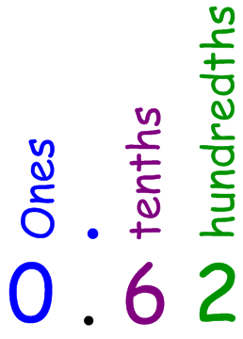  0.6 looks like:  0 0.1 0.2 0.3 0.4 0.5 0.6 0.7 0.8 0.9 1  0.7 looks like:  0 0.1 0.2 0.3 0.4 0.5 0.6 0.7 0.8 0.9 1  Let’s zoom in, 0.62 would look like so – it’s larger than 6 but smaller than 7…  0.5 0.6 0.7 0.8
Year 4 | N/C: recognise and write decimal equivalents to 1/4, 1/2, and 3/4  LO - I can recognise and write decimal equivalents of ¼, ½ and ¾, ^{n}/₁₀ and ^{n}/₁₀₀ | Fractions to decimals and vice versa  1/2 = 0.5  0 0.5 1  3/10 = 0.3  1/10 2/10 3/10  0 0.1 0.2 0.3 0.4 0.5 0.6 0.7 0.8 0.9 1  2/5 = 0.4  0 0.2 0.4 0.6 0.8 1  Thought process: Divide the denominator by the numerator.  1/2 as a decimal = 2 ÷ 1 = 0.5
 | N/C: round decimals with one decimal place to the nearest whole number  LO- I can round decimals with one decimal place to the nearest whole number | Place value in decimal numbers – Rounding  0.7 rounded to the nearest whole number…  0 0.1 0.2 0.3 0.4 0.5 0.6 0.7 0.8 0.9 1  Thought process: we can only go to the nearest whole numbers; here they are 0 and 1. We need to remember the rule for rounding. An easy rhyme to remember;  1, 2, 3, 4 - down to the floor. 5, 6, 7, 8, 9, - up we climb.  0.7 rounded to the nearest whole number… “5, 6, 7, 8, 9 – up we climb,” we therefore will round up to 1; our nearest whole number.  0 0.1 0.2 0.3 0.4 0.5 0.6 0.7 0.8 0.9 1
Year 4 | N/C: add and subtract fractions with the same denominator  LO - I can add and subtract fractions with the same denominator | Adding fractions with the same denominator  1/4 + 2/4  1/4  + +  2/4  = =  3/4  Stage 4 - Reverse for subtraction
Year 5 | N/C: add and subtract fractions with the same denominator and multiples of the same number.  LO- I can add and subtract fractions with the same denominator and related fractions including writing mathematical statements that exceed 1 as a mixed number: (e.g. 2/5 + 4/5 = 6/5 = 1¹/₅) | Adding fractions with different denominators  1/3 + 2/4  1/3  + +  2/4  We need find a common denominator that appears in both multiplication tables…12. Split two bars into 12  1/3 + 2/4 becomes 4/12 + 6/12  4/12  + +  6/12  = 10/12
Year 5 | N/C: recognise the percent symbol (%) and understand that percent relates to "number of parts per hundred", and write percentages as a fraction with denominator hundred, and as a decimal fraction  LO- I can write simple fractions as percentages and decimalized percentages (e.g. ½ = 50% = 0.5) | Fractions to decimals to percentages  1/2 = 0.5 = 50%  0 0.5 1  0% 50% 100%  3/10 = 0.3 = 30%  0 0.1 0.2 0.3 0.4 0.5 0.6 0.7 0.8 0.9 1  0% 10% 20% 30% 40% 50% 60% 70% 80% 90% 100%  2/5 = 0.4 = 40%  0 0.2 0.4 0.6 0.8 1  0% 20% 40% 60% 80% 100%  Thought process: Divide the denominator by the numerator and multiply by 100  1/2 as a decimal = 2 ÷ 1 = 0.5 x 100 = 50%  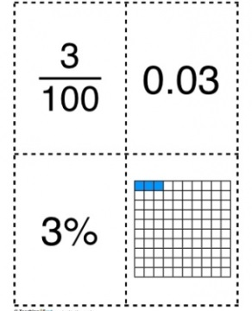  1/10 = 10%
Year 5 | N/C: recognise mixed numbers and improper fractions and convert from one form to the other and write mathematical statements  LO- I can recognise mixed numbers and improper fractions and convert from one form to the other | Mixed numbers to improper fractions and vice versa  Convert 2 1/3 into an improper fraction.  1 1 1/3  Convert these now into thirds, how many thirds are there?  1/3 1/3 1/3 1/3 1/3 1/3 1/3  = 7/3  Thought process: Multiply the whole number by the denominator, to find the improper fraction for the whole number and then add the extra numerators.  e.g. 2 = 6/3 + 1/3 = 7/3

Year 6 | I can use common factors to simplify fractions and use common multiples to express fractions in the same denomination | Thought Process:  Use knowledge of multiplication tables to identify common factors to simplify fractions.
 | I can compare and order any fraction, including fractions >1 | Thought Process: To order fractions, first find equivalent fractions with a common denominator:  - Use knowledge of multiplication tables to identify common denominators (multiples).  - Identify the factor with which to calculate the common denominator and then multiple the numerator by the same factor.  - Order on a number line  - Return to original fractions.
 | I can use percentages for comparison and calculate percentages of whole numbers or measures such as 15% of 360. | Thought Process: To find a percentage of given amount:  - Convert the percentage into a fraction  - Divide amount given by denominator  - Multiply answer by numerator
 | I can recall and use equivalences between simple fractions, decimals and percentages including in different contexts | Thought Process:  - To convert fractions to decimals: numerator divided by the denominator  - To convert decimals to a percentage: multiply the decimal by 100  - Convert decimals to fractions: Identify the place value of tenths, hundredths or thousandths.

