SEND INFORMATION REPORT 2023-24
INCLUSUION TEAM: Amie Ashdown- SENCo 2 days, Anna Russell SEND assistant
SEND Administrator: Joanna Stephens
SEND GOVERNOR: Emma Collins
Tel:01323 482404
Email: a.ashdown@polegate.e-sussex.sch.uk
sen@polegate.e-sussex.sch.uk
Dedicated SEND time: 0.2 Amie Ashdown, 0.5 Anna Russell
Whole school approach
High quality first class teaching and additional interventions are defined through our continual dialogue across the school contributing to our provision management approach. Children requiring interventions are discussed at pupil progress meetings and children who have a higher level of need are placed on school support plans. These documents help us to regularly review and record what we offer EVERY child in our care and what we offer additionally
Underpinning ALL our provision in school is the graduated approach cycle of:
ASSESS

REVIEW PLAN
DO

All teachers are responsible for every child in their care, including those with special educational needs. (see Teaching and learning policy and Special Needs and disabilities Policy and Inclusion policy)
Assess- children are regularly assessed as part of the whole class. Progress is carefully tracked and monitored. Some children may require specific assessments to track progress in smaller steps. Occasionally it may be necessary to assess children using a ‘one off’ formal SEND assessment e.g Dyslexia screening test, Speechlink, language link….)
Plan- all children who have an Education, Health and Care Plan (EHCP) have a plan for their provision. In addition, a small number of children with more complex needs also have an Additional Needs Plan and all children on the SEN register have an Assess Plan Do Review record. It is the responsibility of the class teacher to plan for interventions and additional inclusion strategies that a child may need in their class. Advice on planning can be sought from the Inclusion team and SLT and interventions are discussed at Pupil progress meetings.
Do- It is recognised that Quality First Teaching enables all children with SEND to make the best progress. Teachers plan for individual children as part of the whole class planning process using the specific techniques and strategies to support their individual pupils. Teaching assistants are well trained in SEND and where they have particular expertise, we aim to match them with the children they are working with e.g Makaton, attachment disorder, autism etc
Review- Children progress is regularly reviewed by teachers as part of an ongoing progress. At pupil progress meetings the effectiveness of strategies and interventions are discussed. In addition, Additional Needs/assess plan do review meetings are held at least three times a year and include parents, staff and external agencies (where appropriate). If a strategy or intervention is not proving to be effective we discuss alternative provision and/or involve external agencies in providing advice. Those pupils with an EHC plan will have an annual review in addition to meetings throughout the year.
Having consulted with children, young people and their parents all our provision (internal or external) is based on an agreed outcome approach.
SEND NEEDS
Children and young people’s SEND are generally thought of in the following four broad areas of needs and support:
1.Communication and interaction
We are well supported from CLASS (communication, literacy and autism support service.) We can also access CITES ( children’s integrated therapy services). We run nurture groups, Lego Therapy and THRIVE ftc sessions. We use Communicate in Print to aid children with speech and language difficulties. We screen pupils using Speechlink and Language Link to assess children and plan appropriate programmes. We have a speech and language TA and a specialist Speech and language Consultant that we purchase 1 day a week. The school also promotes philosophy 4 children (P4C) to develop deeper understanding. Some staff are trained in Makaton.
2. Cognition and Learning
We use multisensory approaches as part of our quality first teaching and provide precision style interventions where appropriate. We have 1 specialist dyslexia teacher and 1 Specialist dyslexia TA. They are able to advise on dyslexia strategies to use in class and can carry out the DST (dyslexia screening test) if required. In addition the Assistant Headteacher is also qualified to carry out a range of cognitive assessments. CLASS and the Educational Psychology service can offer support for additional assessments and advice.

3.Social,Emotional and Mental Health
We have a 3 trained THRIVE/ELSA ftc practioners who support children with their emotional wellbeing. In addition we run social skills interventions and nurture groups. Where a child is displaying emotional or mental health issues that interfere with his or her learning other services such as CAHMS, ESBAS are sought.
. 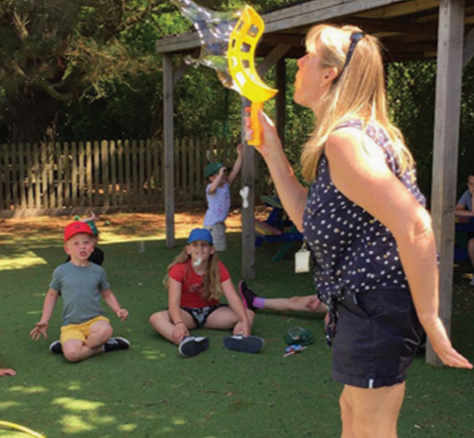
We had a school counsellor/ family support advisor who supports children and families 2 days a week. We run bespoke small good interventions as appropriate.
We have recently purchased a whole school approach to supporting positive mental health.

4. Sensory and Physical
Provision is put in place following the advice of Sensory Needs Service or as a response to needs that arise. Teachers are aware of any SEND and adapt the environment to suit the child. Examples may include enlarging text or considering a child’s seating arrangement. Advice from Occupational Therapy and Physiotherapy are followed up where appropriate. 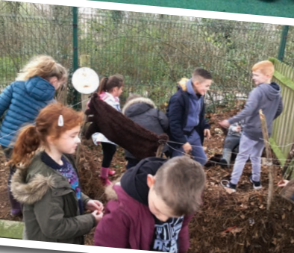
(Reference SEND policy)
We currently have around 106 children receiving some form of SEN and Disability support.
We have internal processes for monitoring quality of provision and assessment of need. These include lesson observations, observations of interventions, work scrutiny, discussions at pupil progress meetings and additional needs plan /provision plan meetings and reviews. The children are regularly assessed as part of the school’s ongoing process. Additional specialist assessments are carried out to identify needs as required. External agencies are also able to provide specialist assessments as required.
Consulting with children, young people and their parents
Involving parents and learners in the dialogue is central to our approach and we do this through:
Action/Event | Who’s involved | Frequency
SEND/FSA parent coffee mornings | SENCo-Amie Ashdown  FSA – Amanda Nippard | 1 x term
SEND meetings (assess plan do review/provision)  EHCP | SENCO  Class teacher  Parents  Other professionals involved  Senco, parents , other relevant professionals | At least 3 times a year  Annually
Pupil voice  Pupil passport  Parent voice | Individual pupils  Individual pupils with class teacher  Parents/carers | As needed  3 times a year for children with ANP  At least3 times a year  At least 3 times a year

Staff development
We are committed to developing the ongoing expertise of our staff.
Areas of expertise within the staff | Specialist Dyslexia Teachers  Reading Recovery  Early Numeracy  Literacy and Speech , Language and Communication  Makaton  THRIVE ftc  Lego Therapy  Speechlink  Pupil Voice  Phonics  Autism  Sensory circuits (occupational therapy programme)  P4C Philosophy for Children  Attachment disorder  Jump ahead  Word aware  Bucket Time –  ELSA

This year we have put in additional training into My happymind, ELSA, Family Support Advisor, Therapeutic thinking, nurture and behaviour as part of our staff development programme.
Considerable thought, planning and preparation goes into utilising our support staff to ensure children achieve the best outcomes, gain independence and are prepared for adulthood from the earliest possible age. We have a highly trained team of teaching assistants. Careful consideration is given to the expertise of staff and the needs of the children.
Finance
Our notional SEND budget last year (2022/23) was £ 385,815.61
Our actual SEND expenditure was £ 445,196.00

School partnerships and transitions
We have worked closely with our nursery school and pre-schools to ensure a smooth transition into school. Where a child comes into school with a high level of need, we have additional meetings and adapt their transition to school to meet their needs.
We work closely alongside Willingdon Secondary School and run a smooth transition programme for more vulnerable pupils. Where a child transfers to another secondary school, we liaise closely with the receiving school providing additional support and taster days where necessary. Polegate school are a Flagship School for IQM and have close relationships with other IQM schools. We are also a Behaviour Hub Lead School and support schools with this DFE behaviour project.
Complaints
If a parent is concerned about anything to do with the education that we are providing at our school, they should in the first instance discuss the matter with the child’s class teacher. In our experience most matters of concern can be resolved positively in this way. All teachers work very hard to ensure that each child is happy at school, and making good progress, they naturally want to know if there is a problem, so they can take action before it seriously affects the child’s progress.
Where parents feel that a situation has not been resolved through contact with the class teacher, or that their concern is of a sufficiently serious nature they should make an appointment to discuss it with the Headteacher. The Headteacher considers any such complaint very seriously and investigates each case thoroughly. Most complaints are normally resolved by this stage.
Should any parents have a complaint about the Headteacher, they should first make an informal approach to one of the members of the governing body, who is obliged to investigate it. The governor in question will do all s/he can to resolve the issue through a dialogue with the school, but if parents are unhappy with the outcome, they can make a formal complaint, as outlined below.
Only if an informal complaint fails to resolve the matter should a formal complaint be made to the governing body. This complaint must be made in writing, stating the nature of the complaint, and how the school has handled it so far. The parent should send this written complaint to the chair of governors.
The governing body must consider all written complaints within three weeks of receipt. The governing body has nominated 2 members to serve on the complaints committee to ensure that sufficient members are available to hold a meeting to discuss the complaint and will invite the person making it to attend the meeting, so that s/he can explain the complaint in more detail. The school gives the complaint at least three days’ notice of the meeting.
After hearing all the evidence, the governors will consider their decision and inform the parent about it in writing. The governors do all they can at this stage to resolve the complaint to the satisfaction of the parents.
If the complaint is not resolved, a parent may make representation to the LA. Further information about this process is available from the school or LA. A further meeting is chaired by an independent person, who considers all the evidence and makes a judgement in an attempt to resolve the complaint.
If any parent is still not content that the complaint has been dealt with properly, then s/he is entitled to appeal to the Secretary of State for Education.
(Reference complaints policy)
Challenges this year
We intend to closely monitor the procedures we have put in place and ensure high quality provision remains in place for all children. Embedding the behaviour policy throughout the school is a target for the forthcoming year. Mental Health and Emotional Wellbeing will be a high priority for pupil wellbeing , staff and parent wellbeing. We have invested in developing a whole school approach ‘myhappymind’ to meet the needs of all our school community. We hope to provide high quality provision with a reduction in external services. We aim to ensure pupils with SEND are supported to meet our school vision of ‘Learning without limits.’
Further development
Our strategic plans for developing and enhancing SEND provision in our school include :
- Developing monitoring strategies to assess the effectiveness of interventions
- Revisit Dyselxic Awareness priorities to ensure consistency across the school
- Adopt a whole school approach to support positive mental health
- Staff development focus on mental health and wellbeing.
- Maintain IQM Flagship status
- Apply for Gold School Impact Resilience Award
- Ensure SEND pupils make accelerated progress

In preparing this report we have included staff and parents through the think tank meetings.
Relevant school policies underpinning this report include
SEND Policy
Inclusion Policy
Accessibility Policy and Plan
Teaching and Learning policy
Legislative Acts taken into account when compiling the report include:
Children’s and Families Act 2014
Equalities Act 2010
Mental capacity Act 2005
SEND Green paper 2022
This report was updated by A Ashdown
This policy was updated 5.09.23
Ratified by Governors…………………………………
Review due…………………………………
Head teacher: Mrs Deborah Jones
Special Educational Needs Co-ordinator: Miss Ashdown
Chair of Governors: Elizabeth Latter

