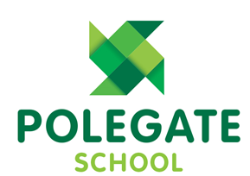

School Uniform Policy
2022-2023

School uniform plays a key role in promoting pride, self-confidence, and a feeling of belonging within the student body. These factors contribute to students' wellbeing, removing the additional pressures of deciding what to wear and added stress of meeting the expectations of their peers.

Date adopted by Governing Body: | September 2022
Date to be reviewed: | September 2023

Winter Uniform | Summer Uniform | PE kit
Grey or Black trousers, skirt, pinafore dress or culottes | Green Gingham Checked Dress (Optional)  Grey or black Trousers, skirt or shorts | White Polegate Logo T-Shirt (Purchased Price & Buckland)  Plain White Polo shirt
Polegate School Jumper or Cardigan  (Purchased Price & Buckland)  Plain dark green jumper or cardigan | Polegate School Logo Jumper or Cardigan  (Purchased Price & Buckland)  Plain dark green jumper or cardigan | Black Polegate School Logo Hooded Jumper  (Purchased Price & Buckland)
Polegate School Logo polo shirt.  (Purchased Price & Buckland)  Plain White Polo shirt or White Shirt/Blouse | Polegate School Logo polo shirt.  (Purchased Price & Buckland)  White Polo shirt or White Shirt/Blouse | Black Polegate School Logo shorts or jogging bottoms  (Purchased Price & Buckland)  Plain black shorts, joggers or leggings (No Logos)
Grey or White Socks  Grey Tights | Grey or White Socks | Black Trainers
Black School Shoes  (No Trainers) | Black School Shoes  (No Trainers)
Polegate logo Sunhat
(Purchased Price & Buckland)
Plain Green Sunhat

Only small stud earrings and jewellery of religious or cultural significant to be worn. Earrings to be removed for Swimming lessons.
Nail varnish, temporary tattoos and hair dye are to be removed before the school day.
Long hair must be tied back, hair styles should be natural colour and smart in appearance. Hair bands to be small, discreet and in school colours (Green, Black or Grey). No shaved patterns or close shaving.

